

|  |
| --- |
| Inventory Features List  Super petro chemical limited |
| REFERENCE: GW/ERP/Features list |
|  |
| **Genweb2 Ltd.** |
| **23-Nov-21** |

# 

# Document Information

|  |  |
| --- | --- |
| Document Name | Inventory Features List |
| Document Author | Rashedul Alam |
| Document review | Mahfuzur Rahman |
| Document Version | 1.1 |
| Release Date | 23th Nov, 2021 |

# Document History

|  |  |  |  |  |  |
| --- | --- | --- | --- | --- | --- |
| A=Added, M=Modified, D=Delete | | | | | |
| **Version No** | **Date** | **Section No** | **A/M/D** | **Description of Change** | **Author** |
| 1.0 | 23-Nov-2021 |  | A | Initial | Rashedul Alam |
| 1.1 | 30-Nov-2021 |  | A | Loan lending & borrowing line chart remove, PR done, PR print, PO print, Product & indent setting | Rashedul Alam |

Contents

A. Document Information 2

B. Document History 2

1. Introduction 5

2. Configuration 5

2.1 Create Indent type by Inventory Manager 5

2.2 Create Warehouse by Inventory Manager 6

2.3 Create Locations by Inventory Manager 7

2.4 Create Operation type by Inventory Manager 8

2.5 Create Unit of measure by Inventory Manager 9

2.6 Create Product by Inventory Manager 10

3. Indents 11

2.1 Indent raise by employee 12

3.2. Indents approval 13

3.2.1 Indents approval by Indent approver 13

3.3. Indents Setting 14

4. Issue Products 15

4.1 Issue Product creation by Inventory Manager 15

4.2 Partial Issue Product creation by Inventory manager 16

5. Issue PR 17

5.1 Issue PR Creation with indent by Inventory user or Manager 18

5.2 PR Creation without indent by Inventory user or Manager 18

5.3 PR Validate by Plant In charge 19

5.4 PR approval by Head of procurement 20

5.5 PR Done by Inventory manager 22

6. Gate in 23

6.1 Create Gate in by Gate in Approver 23

7. Receive goods 24

7.1 Receive goods create by Inventory Manager 24

7.2 Partial Receive goods creation by Inventory manager 26

7.3 Can be received over by Inventory manager 27

8. Quality Control 28

8.1 Quality Control create by Inventory user/Inventory Manager 28

8.2 Partial Quality control creation by Inventory manager 29

9. Sound stock 30

9.1 Sound stock Update by Inventory Manager 30

9.2 Partial Sound stock creation by Inventory manager/user 31

10. MRR (Accounts approver) 32

10.1 MRR (Accounts approver) Approved by MRR Accounts Approver 32

10.2 MRR (Final accounts approver) Approved by Plant in charge 33

11. Print MRR 34

11.1 Print MRR View by Plant In charge 34

12. Product on Hands 36

12.1 View on Hands product Inventory Manager 36

13. Inventory Dashboard 37

13.1 Inventory dashboard view by Inventory Manager 37

14. Item loan lending 38

14.1 Item loan lending create by Inventory Manager 38

14.2 Item loan lending Approved by Inventory Manager 39

15. Item Borrowing 40

15.1 Item Borrowing create by Inventory Manager 40

15.2 Item Borrowing Approved by Inventory Manager 41

16. Scrap 42

16.1 Scrap create by Inventory Manager 42

16.2 Scrap Approved by Inventory Manager 43

17. Reports 44

17.1 PR Summary view by Inventory manager 44

17.2 Stock Summary view by Inventory user/manager 45

17.3 Purchase reports view by Inventory user/manager 45

17.4 Loan Lending Reports view by Inventory user/manager 46

17.5 Loan Borrowing Reports view by Inventory user/manager 48

17.6 Stock Transfer view by Inventory user/manager 50

17.7 Stock Consumption reports view by Inventory user/manager 50

17.8 Stock Issue reports view by Inventory user/manager 51

17.9 Stock Issue Due reports view by Inventory user/manager 52

# 1. **Introduction**

The purposes of this document are to clearly identify the customer requirements and provide a detailed document. The customer will read this document and get a clear view the inventory module. It will also help the review team to validate whether the customer requirements have been fulfilled or not.

# 2. Configuration

Some configuration require for Inventory module, Admin user will configure this.

## 2.1 Create Indent type by Inventory Manager

Indent type is require for indent creation.

Inventory Manager will create Indent type using the indent type form.

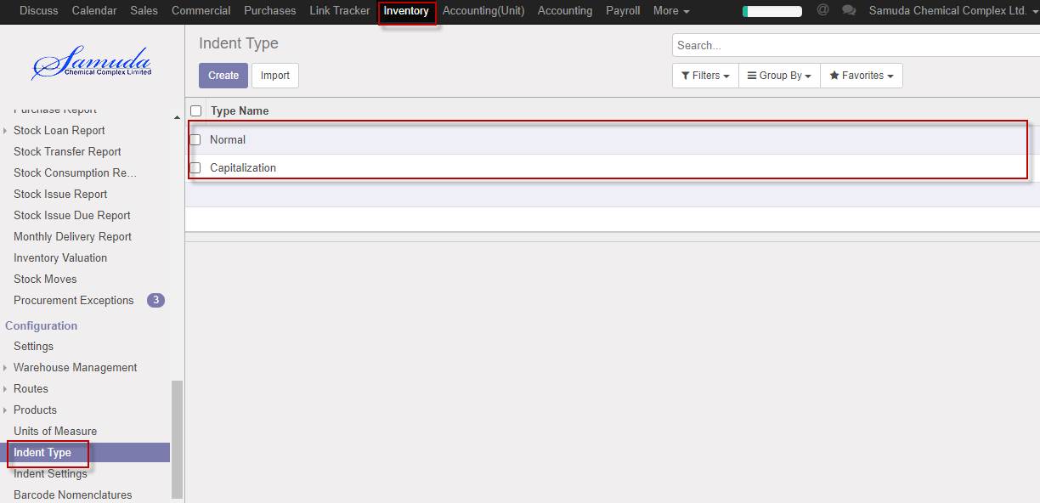

Figure: Indent type List view

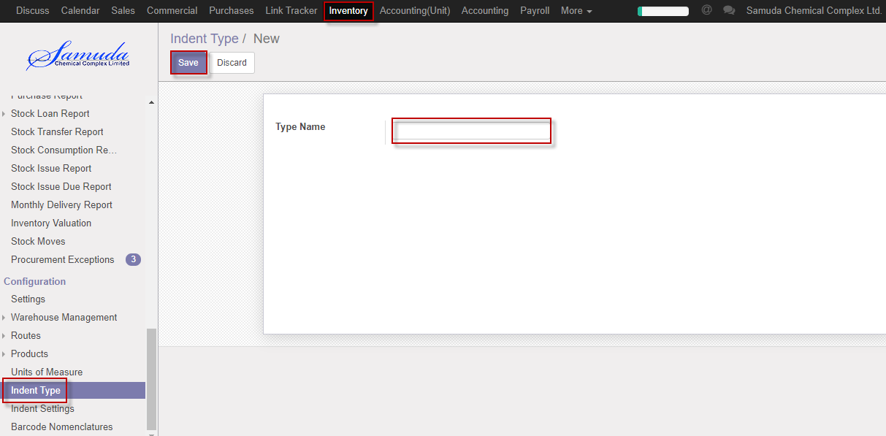

Figure: Create a Indent type

## 2.2 Create Warehouse by Inventory Manager

A **Warehouse** is the actual building/place in which your items are stocked. You can setup multiple warehouses and create moves between warehouses.

Inventory Manager will create Warehouse.

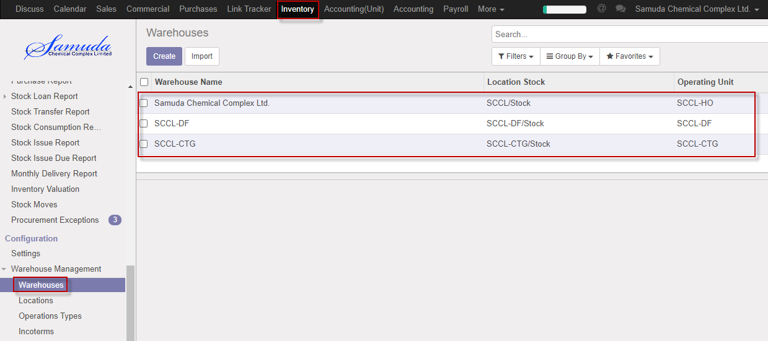

Figure: Warehouse List view

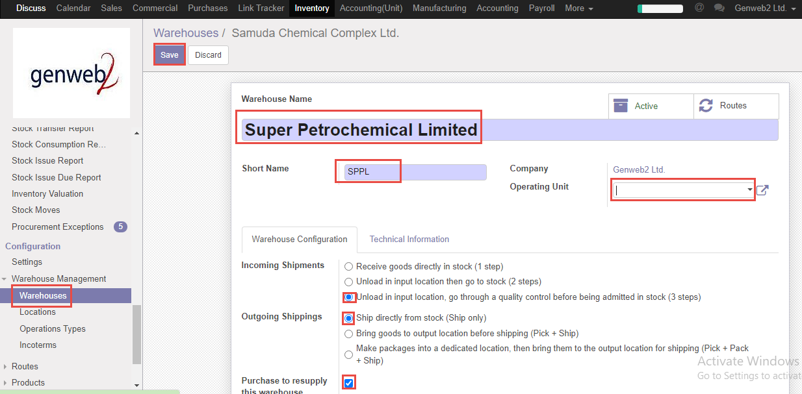

Figure: Create a Warehouse

## 2.3 Create Locations by Inventory Manager

A **Location**, is a specific space within your warehouse. It can be considered as a sub location of your warehouse, as a shelf, a floor, an aisle, etc. Therefore, a location is part of one warehouse only and it is not possible to link one location to multiple warehouses. You can configure as much locations as you need under one warehouse.

There are 3 types of locations:

* The **Physical Locations** are internal locations that are part of the warehouses for which you are the owner. They can be the loading and unloading area of your warehouse, a shelf or a department, etc.
* The **Partner Locations** are spaces within a customer and/or vendor's warehouse. They work the same way as Physical Locations with the only difference being that you are not the owner of the warehouse.
* The **Virtual Locations** are places that do not exist, but in which products can be placed when they are not physically in an inventory yet (or anymore). They come in handy when you want to place lost products out of your stock (in the **Inventory loss**), or when you want to take into account products that are on their way to your warehouse (**Procurements**).

Inventory Manager will create Location.

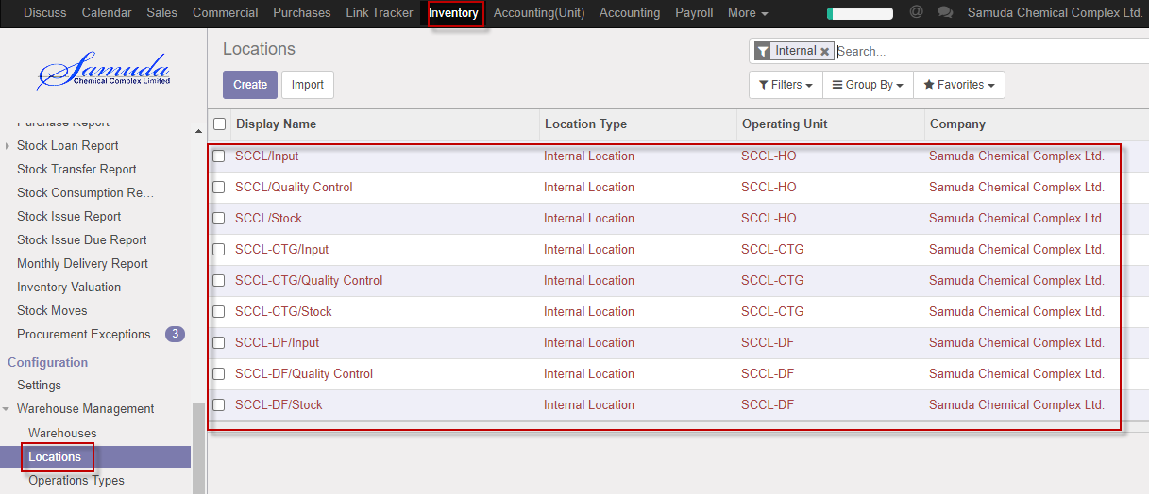

Figure: Location List view

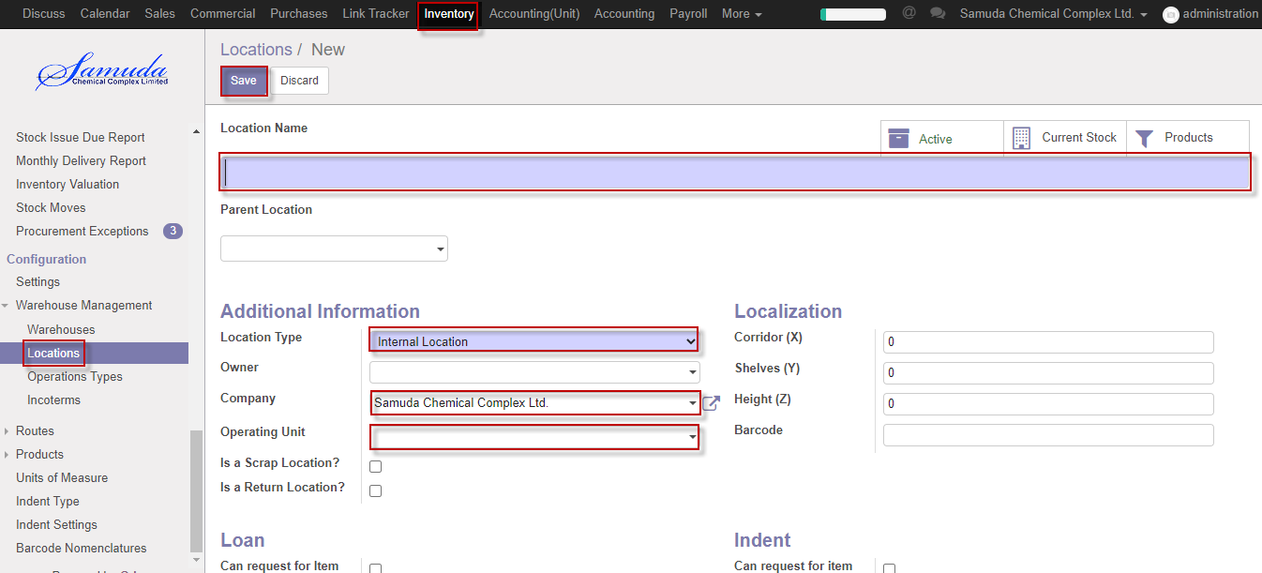

Figure: Create a Location

## 2.4 Create Operation type by Inventory Manager

Inventory Manager will create Operation type. Operation type contains different type of department, warehouse etc.

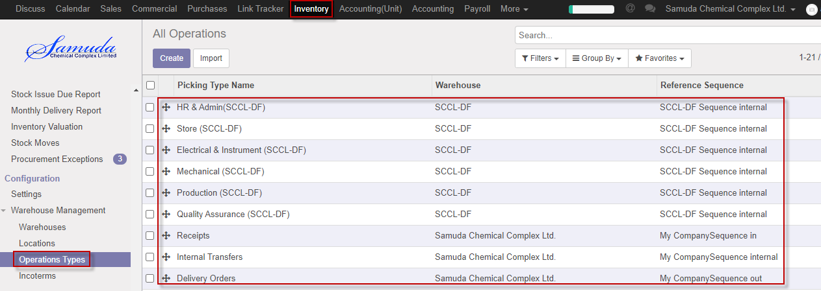

Figure: Operation type List view

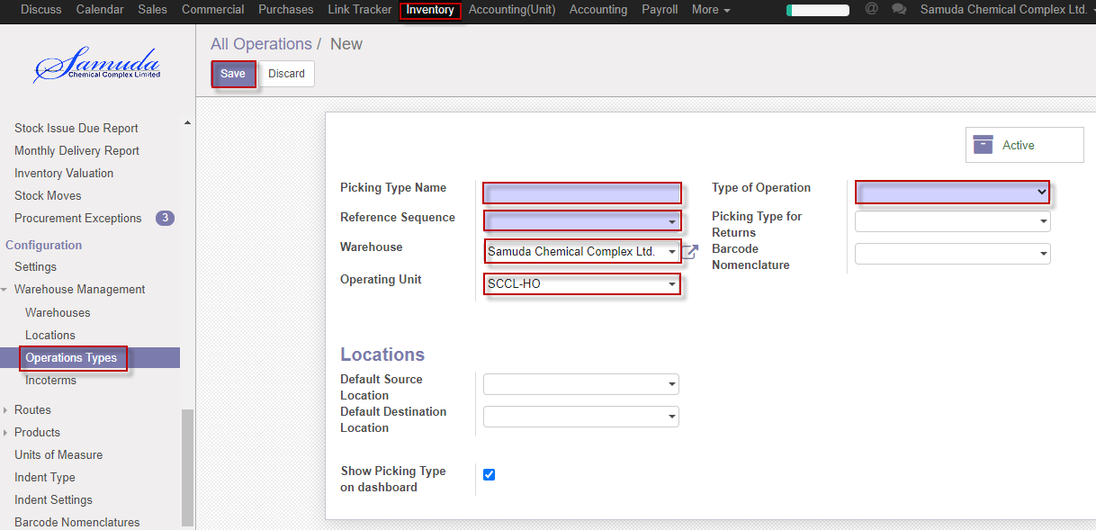

Figure: Create operation type

## 2.5 Create Unit of measure by Inventory Manager

A unit of measurement is a definite magnitude of a quantity, defined and adopted by convention or by law that is used as a standard for measurement of the same kind of quantity. Any other quantity of that kind can be expressed as a multiple of the unit of measurement.For example, a length is a physical quantity. The metre is a unit of length that represents a definite predetermined length. When we say 10 metres (or 10 m), we actually mean 10 times the definite predetermined length called "metre". Measurement is a process of determining how large or small a physical quantity is as compared to a basic reference quantity of the same kind.

Inventory Manager will create Unit of measure.

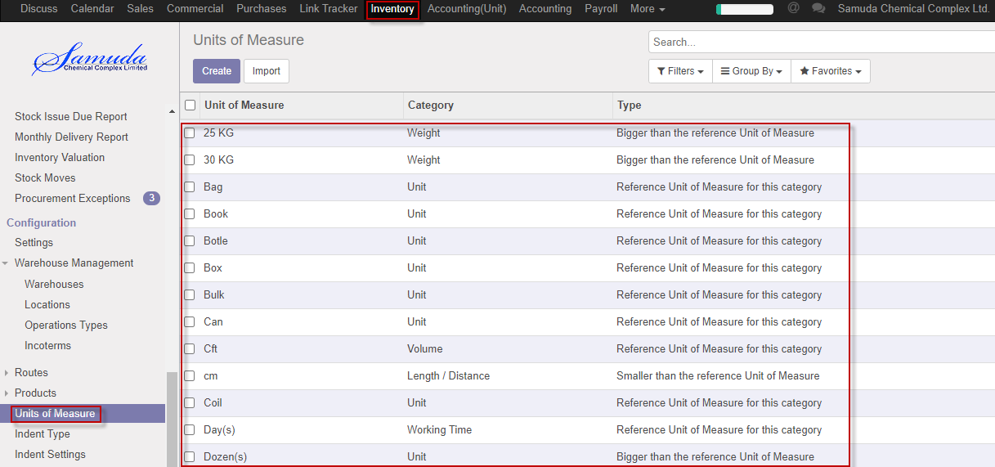

Figure: Unit of measure List view

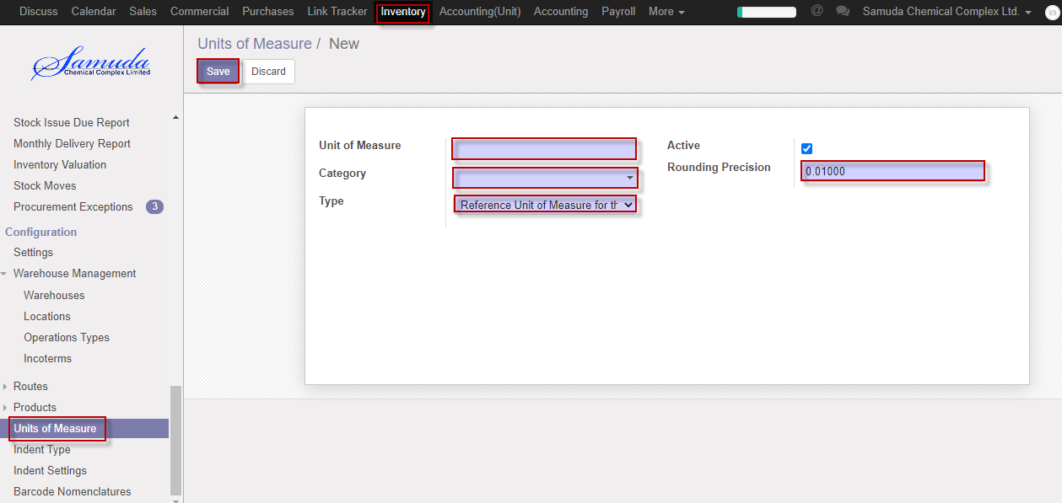

Figure: Create Unit of measure

## 2.6 Create Product by Inventory Manager

Software Product means the Hexagon software product identified in the Order Documents, which includes any associated Hexagon files or media with which the software is provided, any associated templates, data, printed materials, and “online” or electronic Documentation, and any Updates or Upgrades of such Software Products not made the subject of a separate license agreement. The term Software Products shall not include, and no rights of use are granted to User for, Third Party Components, Hexagon products, or dependencies unnecessary to operate products made the subject of the Order Documents, but incidentally delivered within the same files or media. Software Product shall not mean any Third Party Software. For the avoidance of doubt, Cloud Programs and their contents are not “Software Products” as that term is used herein. Software Products are subject to all of the terms and conditions of the End-User License Agreement which the Parties agree will apply to the same; and in the absence of such agreement, then the terms of the End-User License Agreement provided with the Software.

Product Manager will create product.

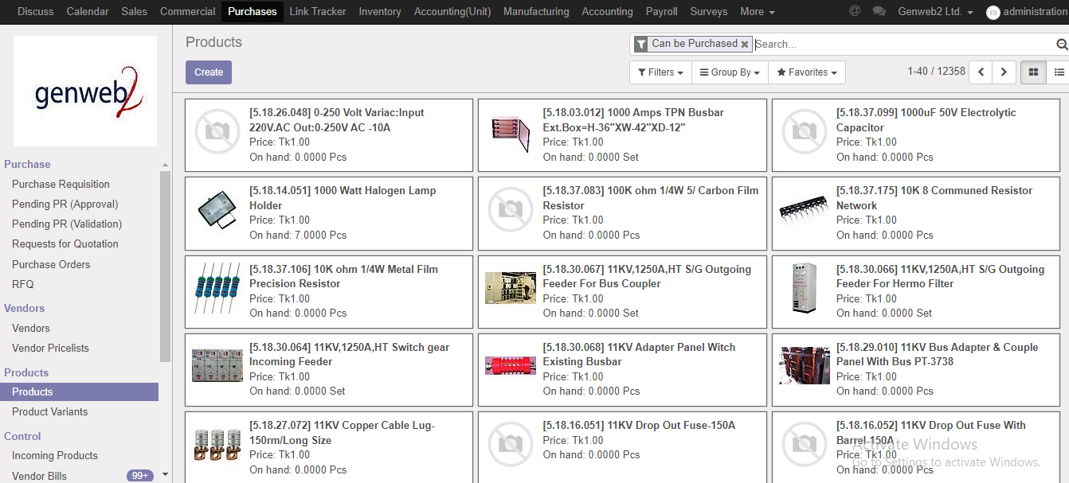

Figure: product kanban view

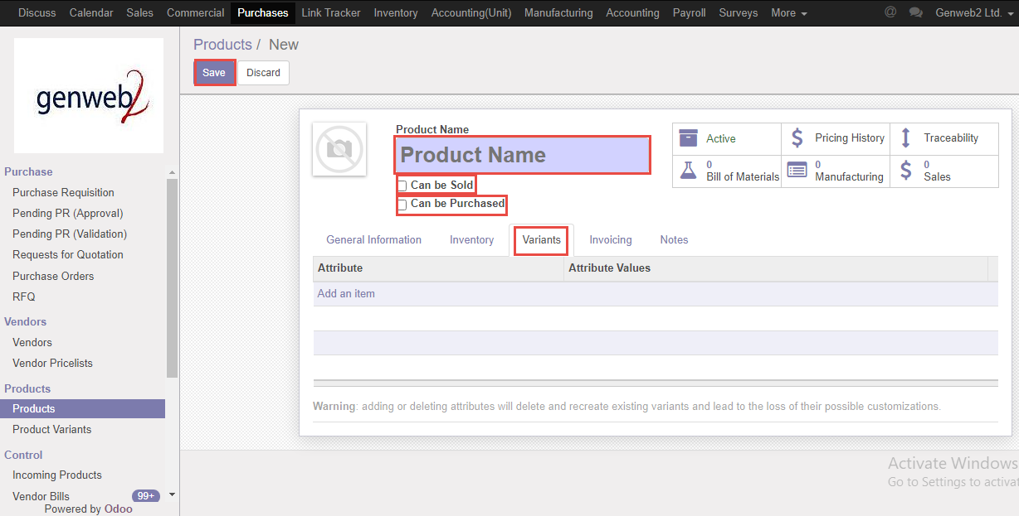

Figure: Create product

# 3. Indents

Each and every Employee will raise indent and Indent approver will approve indents.

If available stock then indent will go for issue indent and will go done state.

If stock not available then will go for Issue PR and it’s another process.

**Indent no:** System will generate auto a unique no after indent creation. Here will first operating number then Year then unique a number.

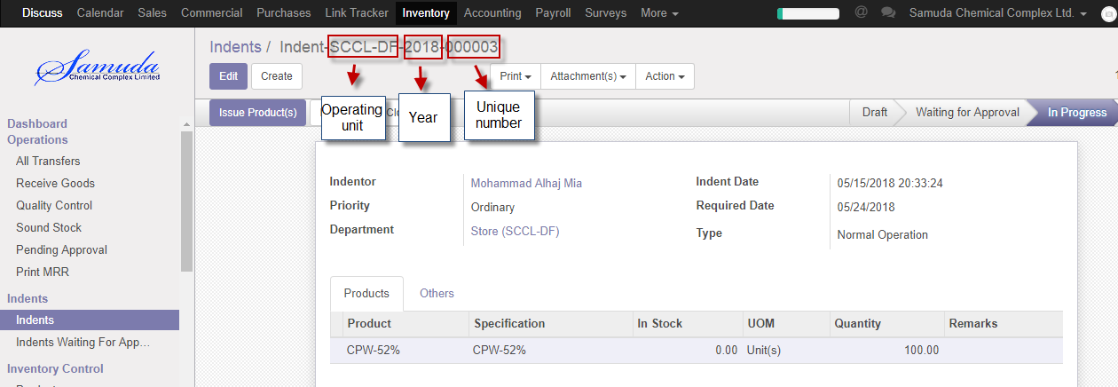

Figure: Indent number

**Indent Search:** Employee is capable to Search indent with variant combination like; with indent no, Company, Department wise etc.

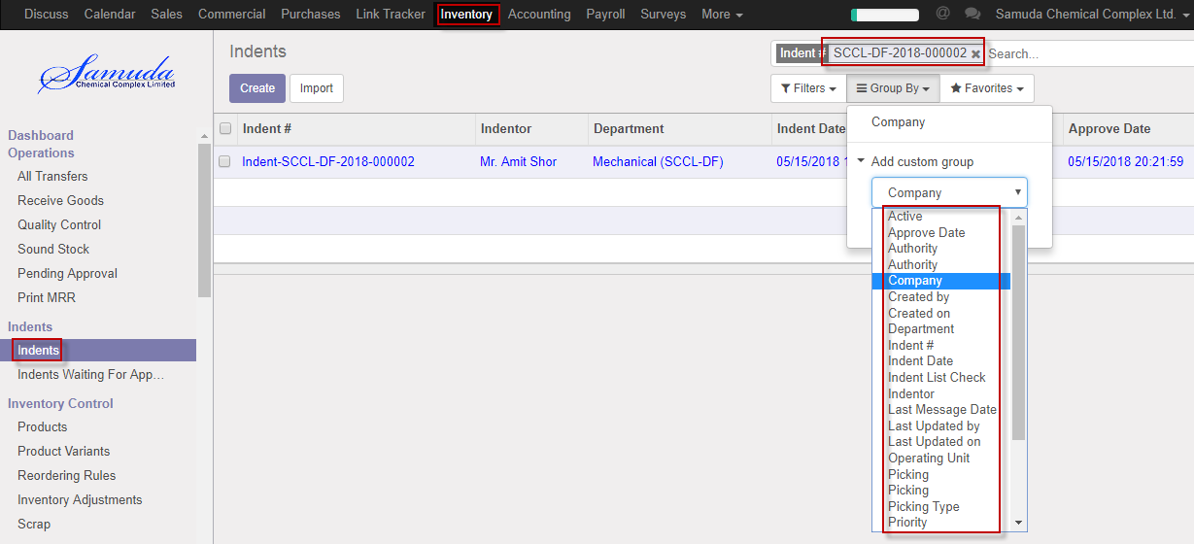

Figure: Indent Search

## 2.1 Indent raise by employee

Indent will be created/Edit by employee or department manager.

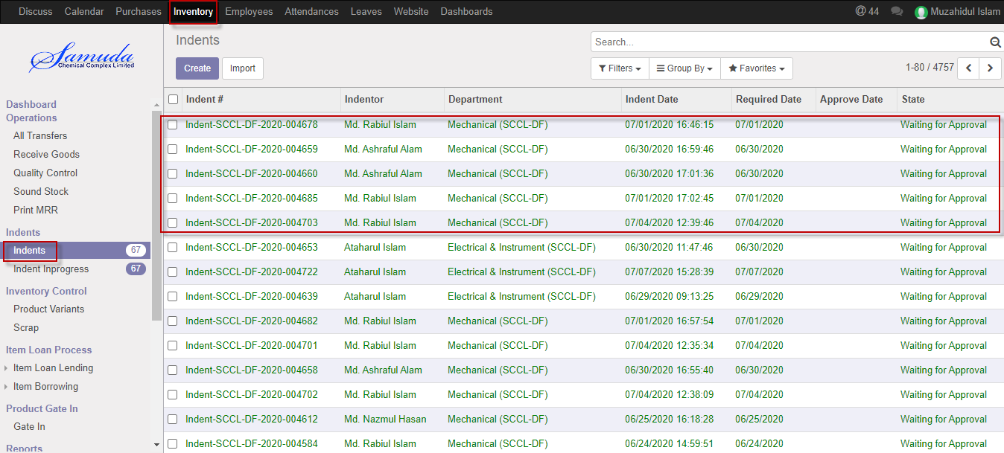

Figure: Indents List view

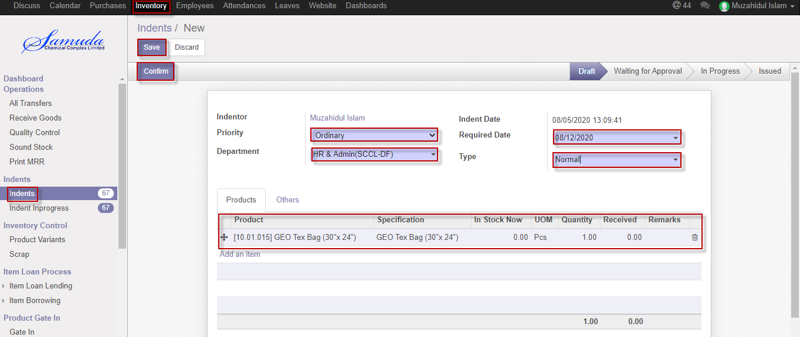

Figure: Create Indents

# 3.2. Indents approval

Each and every indent user will raise indent and Indent approver will approve indents.

## 3.2.1 Indents approval by Indent approver

After raise the Indents, Indents approver will get the notification. He/she can update before approve if require.

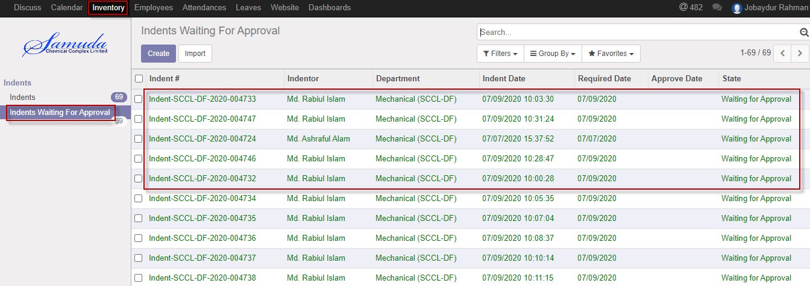

Figure: Indents waiting for approval list view

Indent approver can approve. Select an indent from list then click on **Approve** button 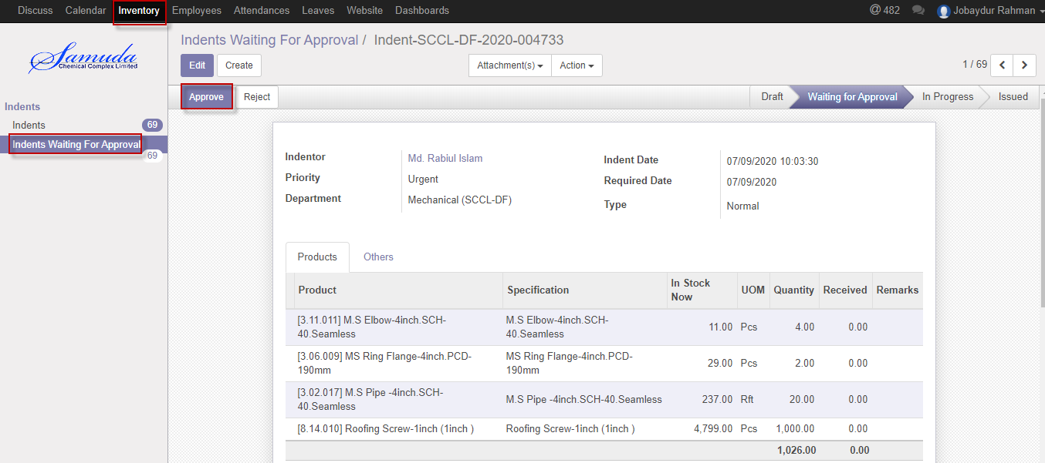

Figure: Indents approved

Indents approver is capable to reject indent by click **Reject** Button.

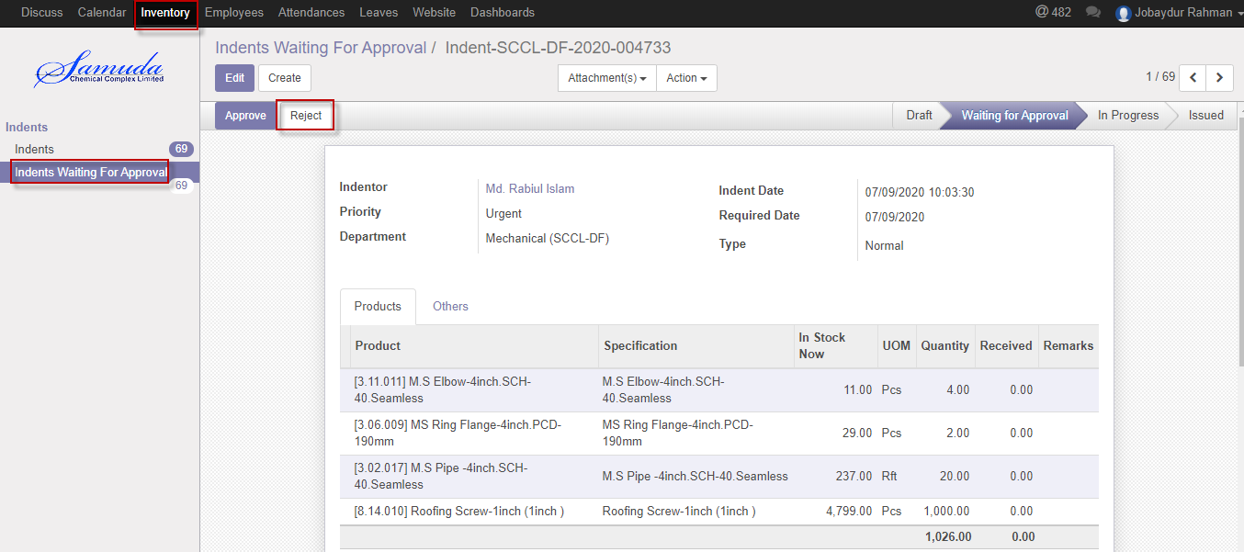

Figure: Indents reject

# 3.3. Indents Setting

Inventory manager will set indent setting. Indent back dating normally can configure here.

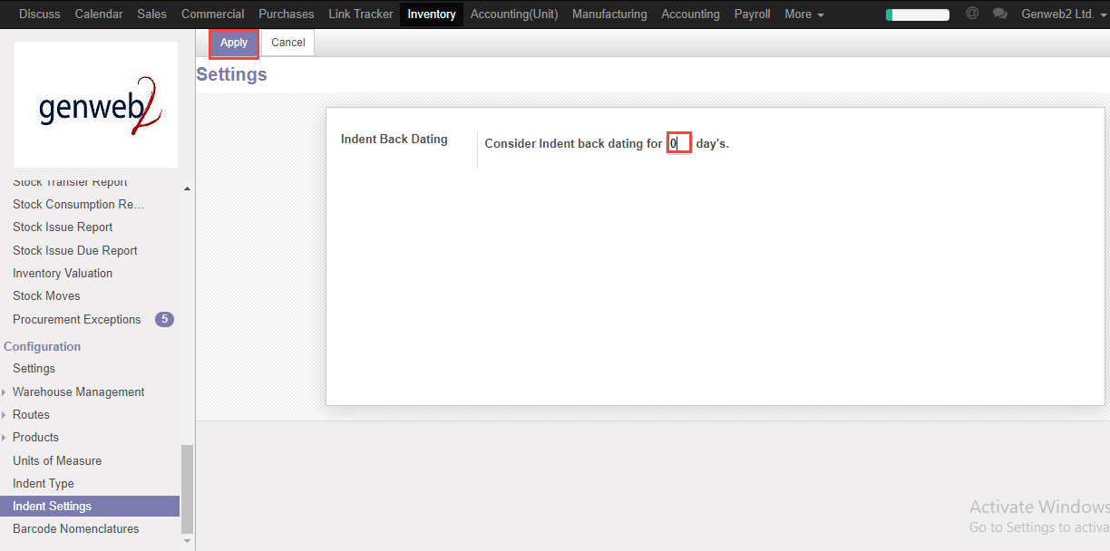

Figure: Indents setting

# 4. Issue Products

If product is available in stock then will go for issue product. Inventory manager will create issue product.

## 4.1 Issue Product creation by Inventory Manager

Issue Products will be created/Edit by Inventory manager.

Inventory manager will create Issue Product

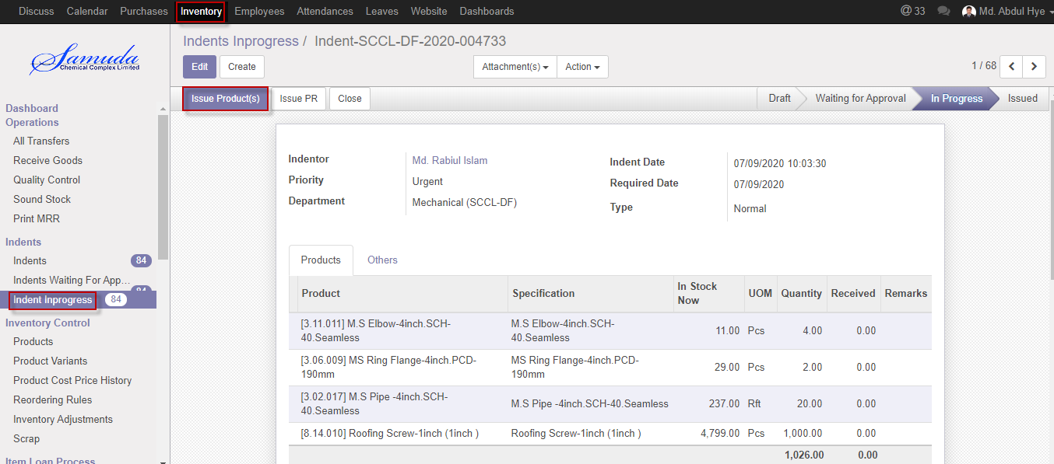

Figure: Create Issue Product

After click validate button will open Yes/No pop up alert then Click **Validate button** then finally issue product will go for done state.

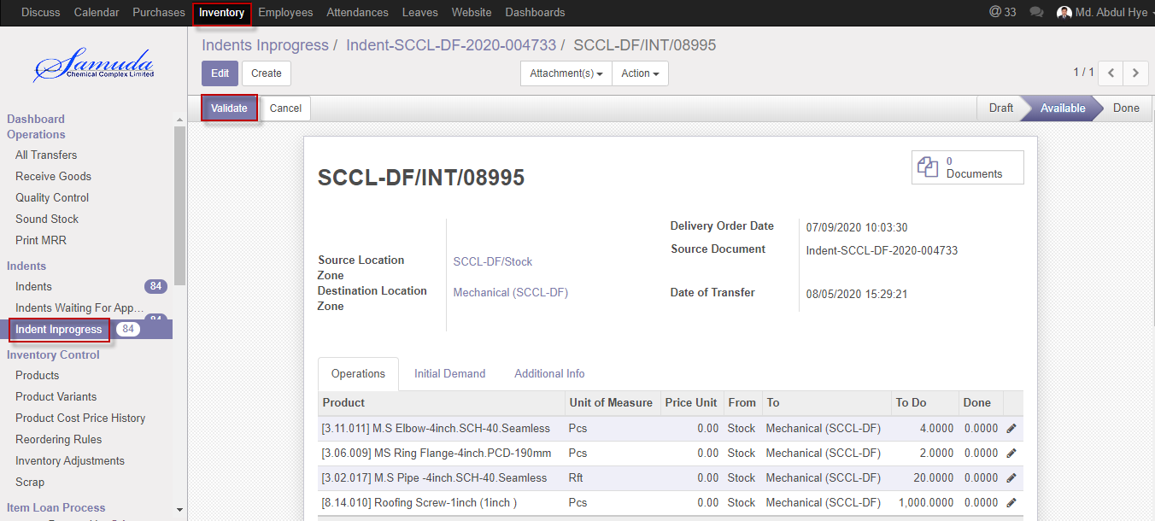

Figure: Validate

Cancel issue product with click **Cancel button.**

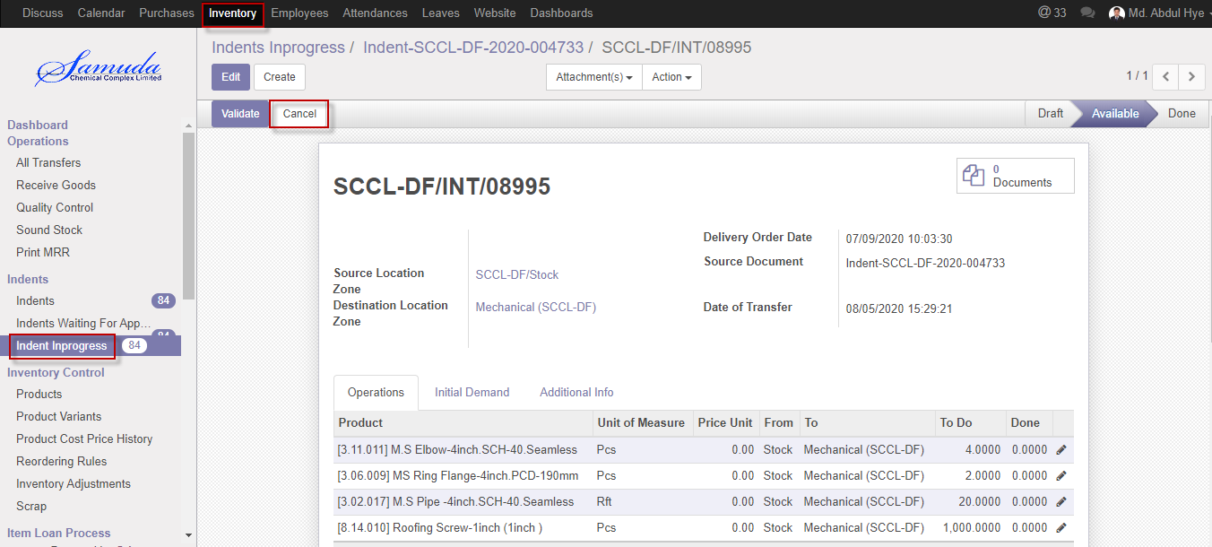

Figure: Cancel issue product

## 4.2 Partial Issue Product creation by Inventory manager

Inventory manager will capable to partial issue product and then will create Backorder.

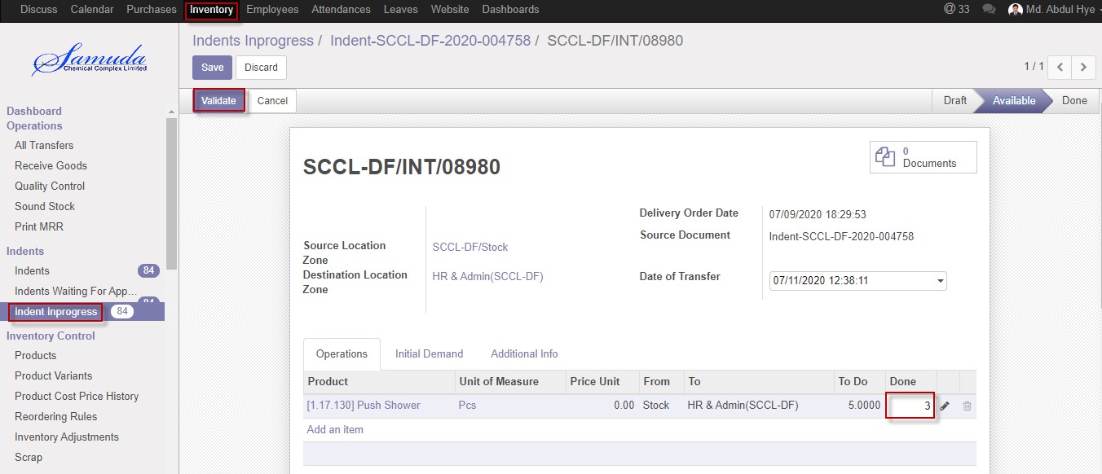

Figure: Partial Issue Product

After click Validate button will open Backorder window then Click **Backorder** buttonthen finally Backorder will go create.

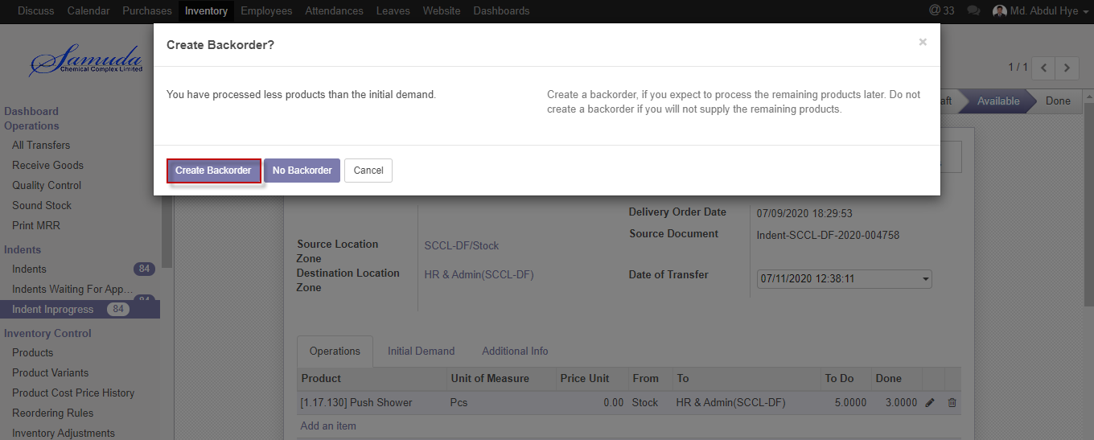

Figure: Create Backorder

# 

# 5. Issue PR

**PR Number:** System will generate auto a unique PR no after Issue. Here will first operating number then Year then unique a number.

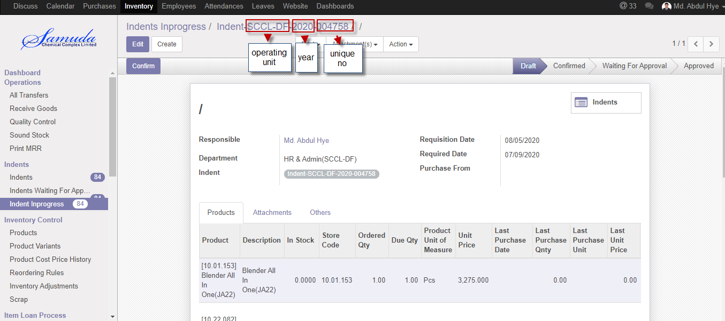

Figure: PR no

## 5.1 Issue PR Creation with indent by Inventory user or Manager

Issue PR will be created/Edit by Inventory user/Manager.

Issue PR is possible for with indent and without indent

PR is possible with multiple indents if user want.PR no has system generated.

Inventory manager/user will create Issue PR

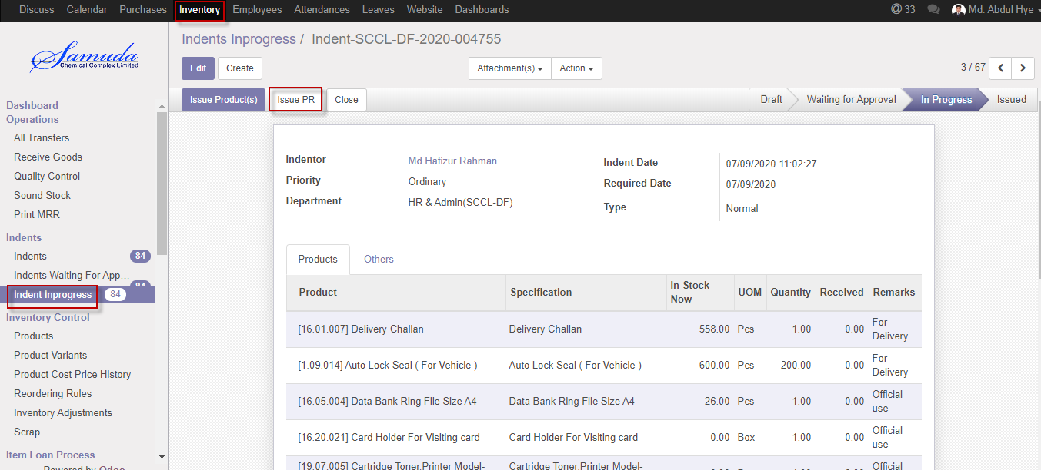

Figure: Issue PR Creation

## 5.2 PR Creation without indent by Inventory user or Manager

PR Without indent will be created/Edit by Inventory user/Manager.

Inventory manager/user will create PR without indent

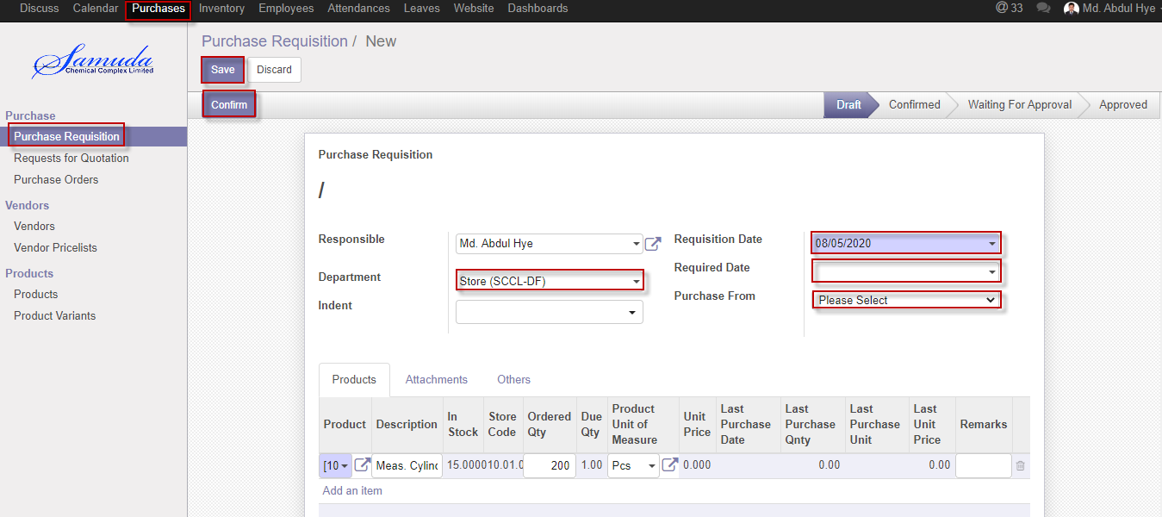

Figure: PR Creation without indent

## 5.3 PR Validate by Plant In charge

Validate PR by click **Validate** Button. Validate by Plant in charge.

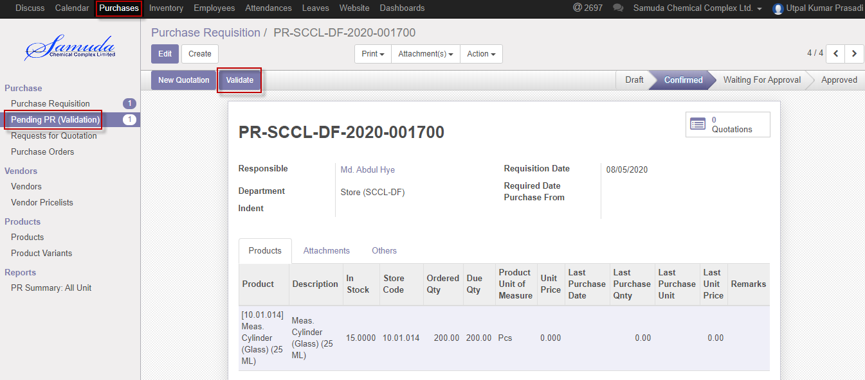

Figure: PR validate

After click Validate button will open following window then Select purchase from, Region type, Purchase By and then **save**

If select own then will go for Issue IoU and select HO then will go for HO procurement for Final approve**.**

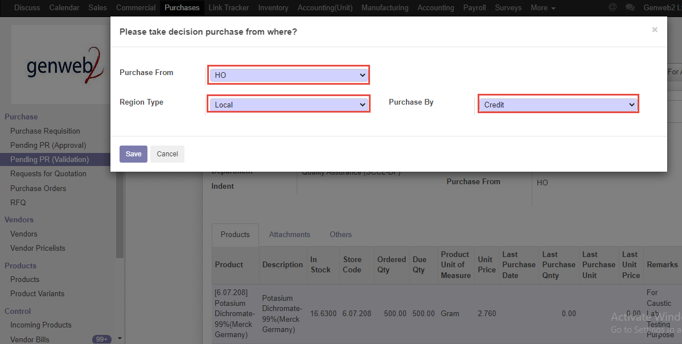

Figure: Purchase form window

## 5.4 PR approval by Head of procurement

After Validate the PR Head of Procurement will get the notification. He/she can approve to click approve button.

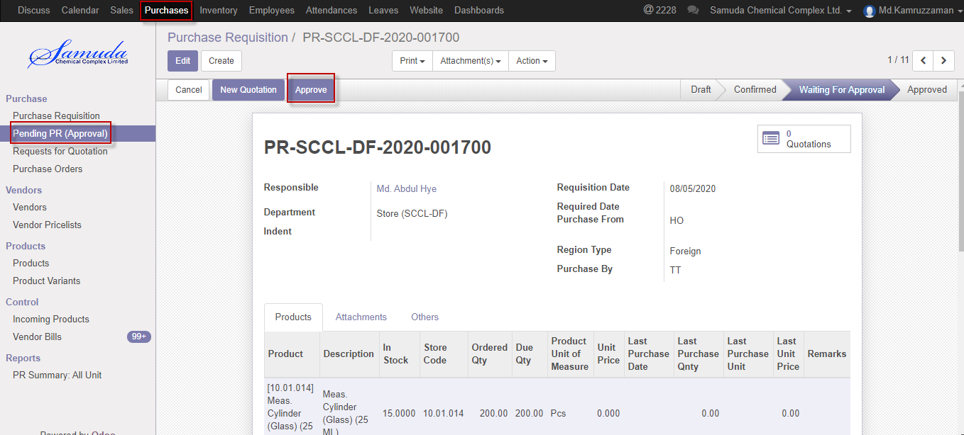

Figure: Pending PR waiting for approval

Following window will open after click **Approve** button then select region type & Purchase by

Select region type Local or and also will select Purchase by which method Cash,Credit.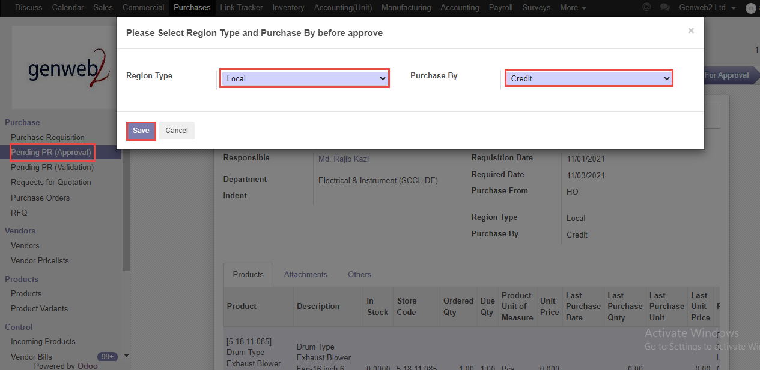

Figure: Purchase method

Following window will open after click **save** button then will ready for New Quotation .New quotation Approve by Head of procurement. 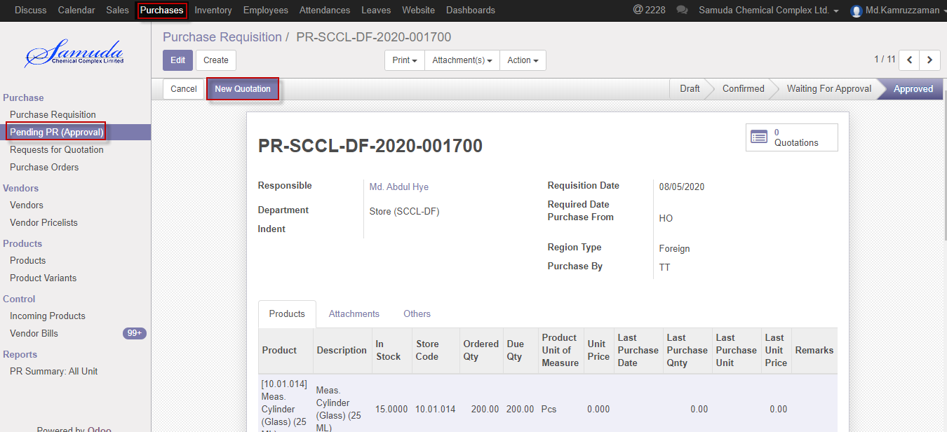

Figure: Create new quotation

Click New quotation button & Select supplier after select all info will come auto and head of procurement is capable to edit then Click **Confirm order** button. Confirmed By Head of Procurement.

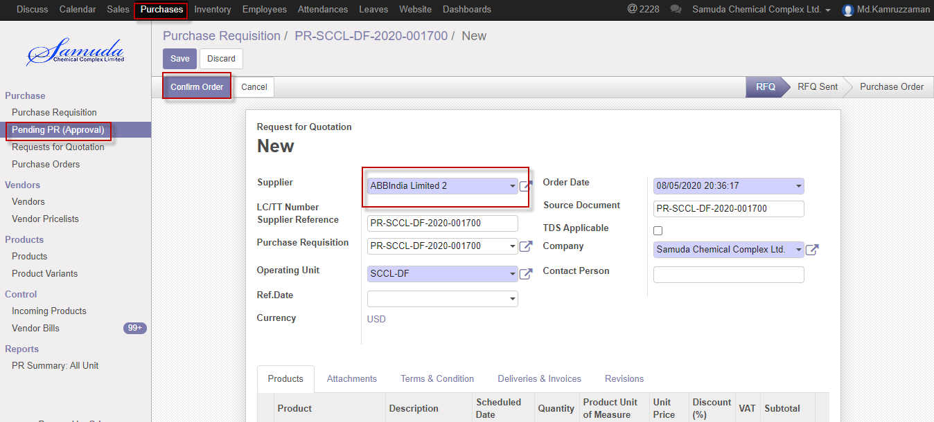

Figure: Confirm order

Following window will open after click Confirm order Button then select region type & purchase by then save then Click Purchase order button then finally Purchase order will approve.



Figure: Purchase method

## 5.5 PR Done by Inventory manager

PR done creation by inventory manager when PR against all due qty will done.

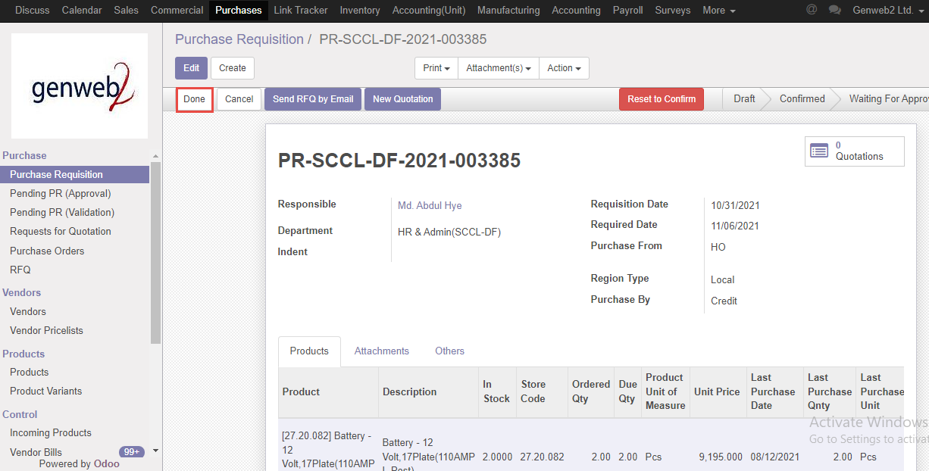

Figure: PR done

# 6. Gate in

In Much Large Company / Organization a Lot of movements take place every day with a Delivery gate pass. It may be Employee or Raw Materials moving from here to there. All these movements of the organization’s premises, factories and companies need to be monitored and controlled.

## 6.1 Create Gate in by Gate in Approver

Gate in will be created/Edit by Gate in approver

Gate in Approver will create Gate in

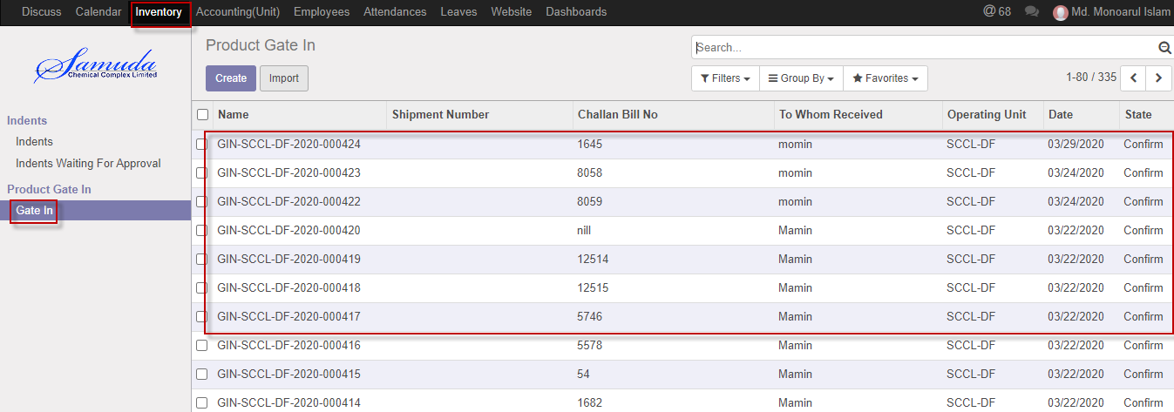

Figure: Gate in List view

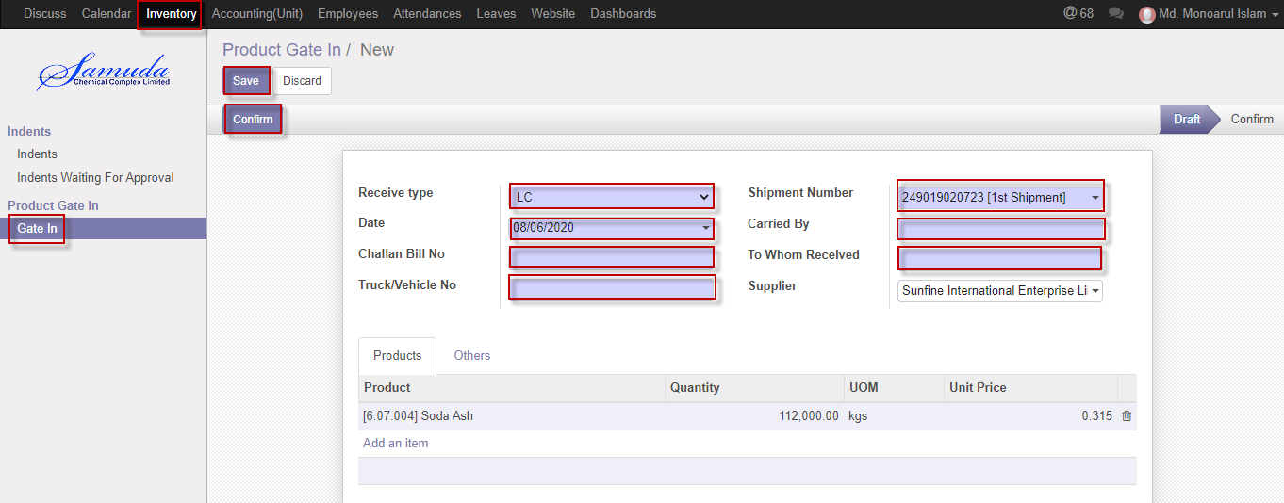

Figure: Create Gate in

# 7. Receive goods

'Goods receiving' is the function of checking items delivered to the business, either coming in as new stock or as supplies. This includes inspecting the quality, condition, and quantity of any incoming goods, and allocating them to a space in the warehouse.

Product price should update applying with average costing method.

Can be received over features also implemented.

Product received will complete mainly with 3 stages

* + - 1. Receive goods
      2. Quality control
      3. Sound stock update

Receive goods are possible also for below cases:

Receive goods against purchase order

Receive goods against a loan

Receive goods against a loan return

Receive goods against faulty goods (Optional)

Receive goods against others

## 7.1 Receive goods create by Inventory Manager

Receive goods will be created/Edit by Inventory user/manager

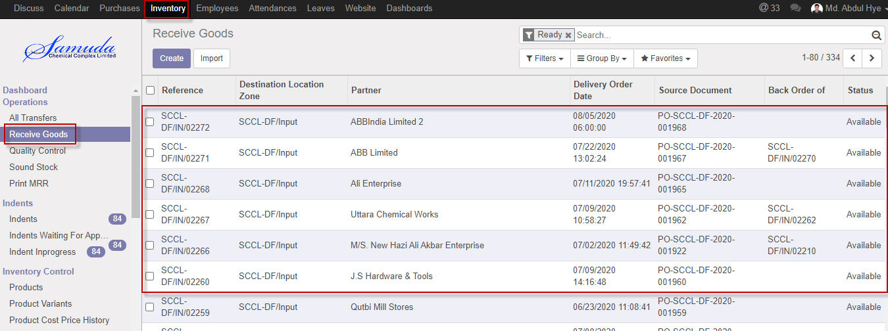

Figure: Receive goods List view

Select goods from list item then receive click **Receive goods button**

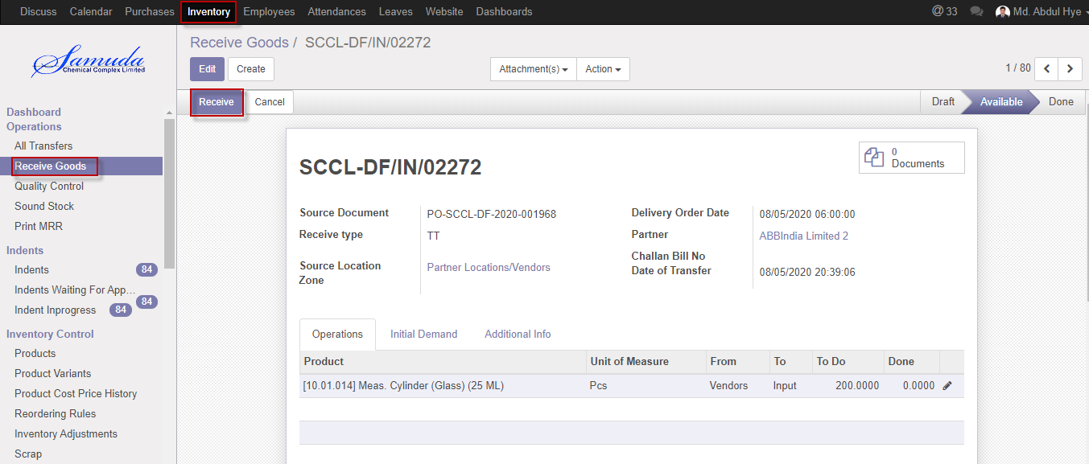

Figure: Receive goods

Cancel Receive goods with click **Cancel button.**

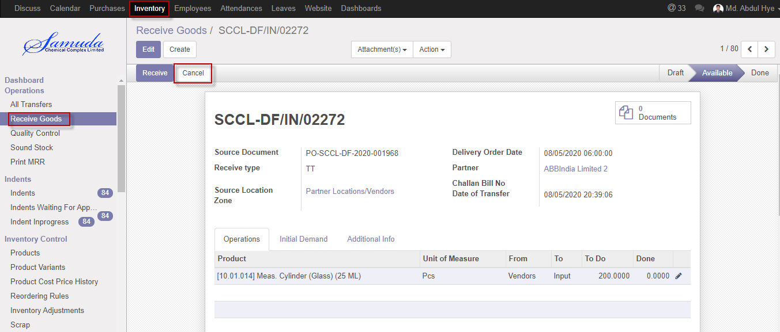

Figure: Cancel receive goods

## 7.2 Partial Receive goods creation by Inventory manager

Inventory manager will capable to partial receive goods and then will create Backorder.

Inventory manager will create Partial Issue receive goods.

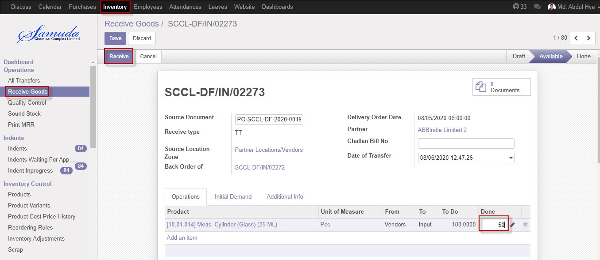

Figure: Partial receive goods

After click Receive button will open Backorder window then Click **Backorder** buttonthen finally Backorder will go create and receive will done.

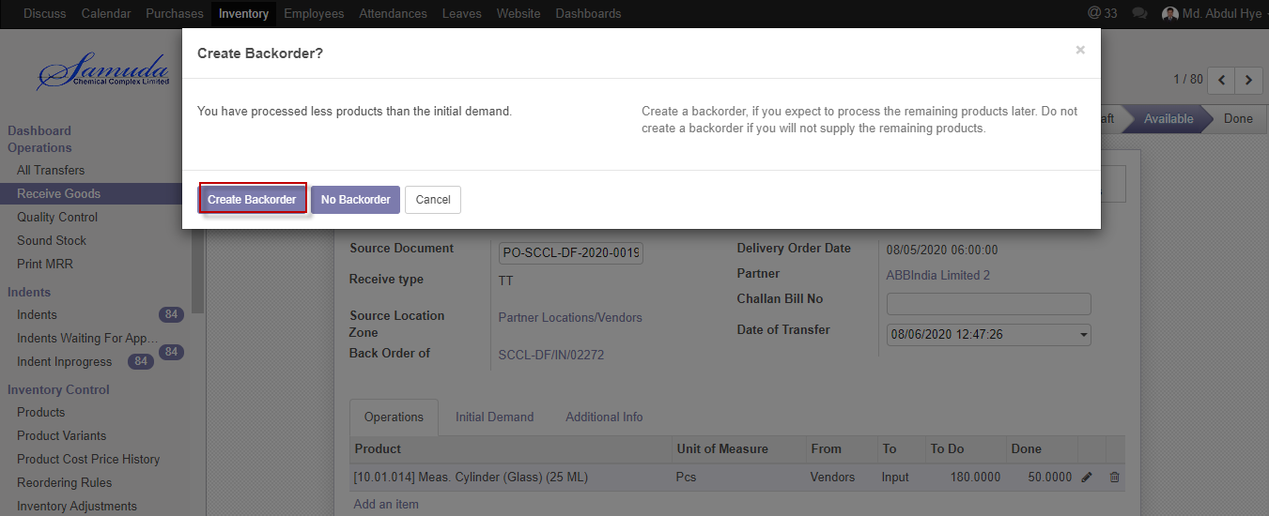

Figure: Create Backorder

## 7.3 Can be received over by Inventory manager

Inventory manager is capable to over received using can be received over features.

If he/she can checked can be received over checked box then will be able to over receive of over qty.

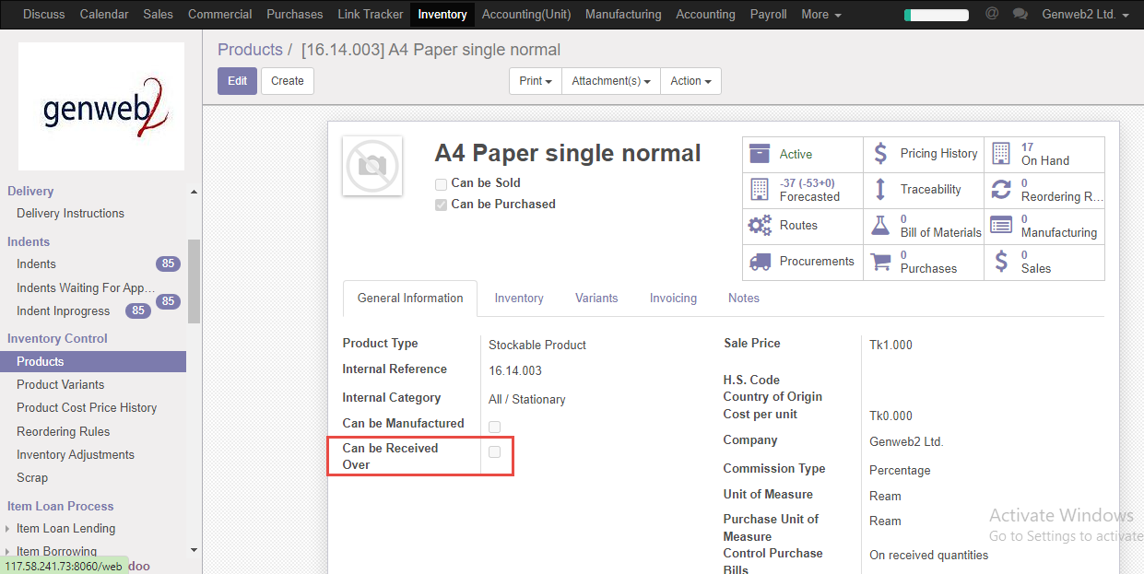

Figure: Can be received over

# 8. Quality Control

Store keeper receives goods which was sent by supplier. QC Authority checks the quality and quantity of goods as per Order. According to QC result they take necessary decision.

If goods are in good quality and exact quantity then QC accept the goods and update the stock of the goods.

If goods are not acceptable and not in exact quantity/quality, QC authority returns the rejected goods to Store Keeper for receive return to Supplier.

## 8.1 Quality Control create by Inventory user/Inventory Manager

Quality control will be Validate/Edit by Inventory manager

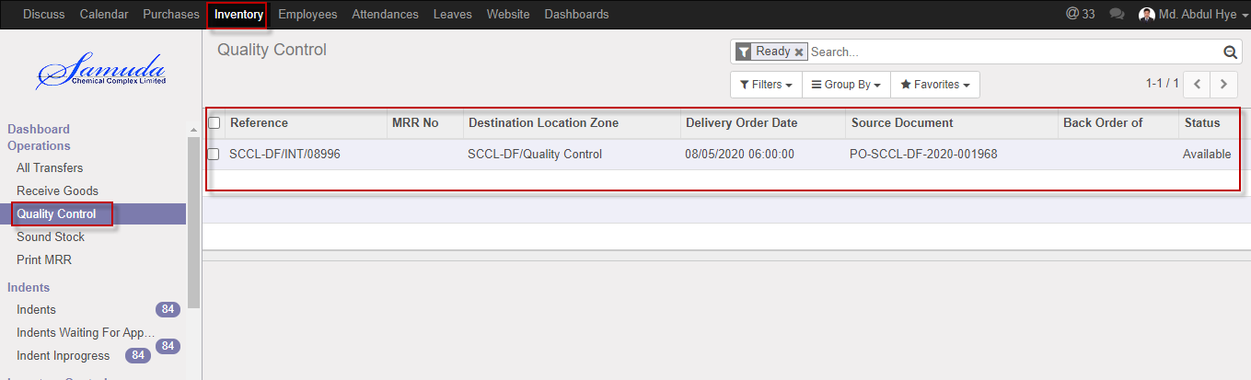

Figure: Quality control List view

Quality control validate will done after click the validate button

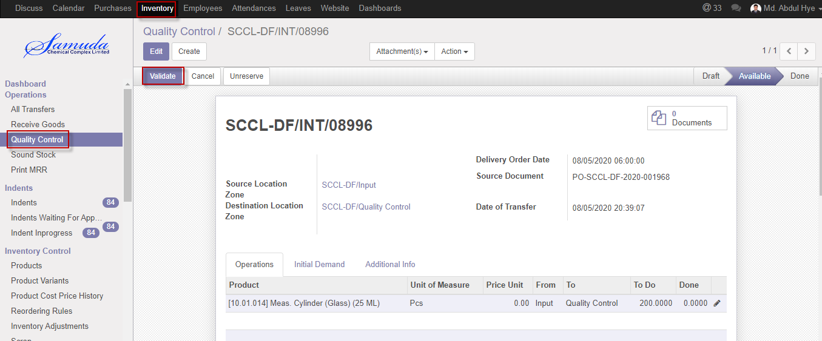

Figure: Quality control validate

Cancel Quality control with click **Cancel button.**

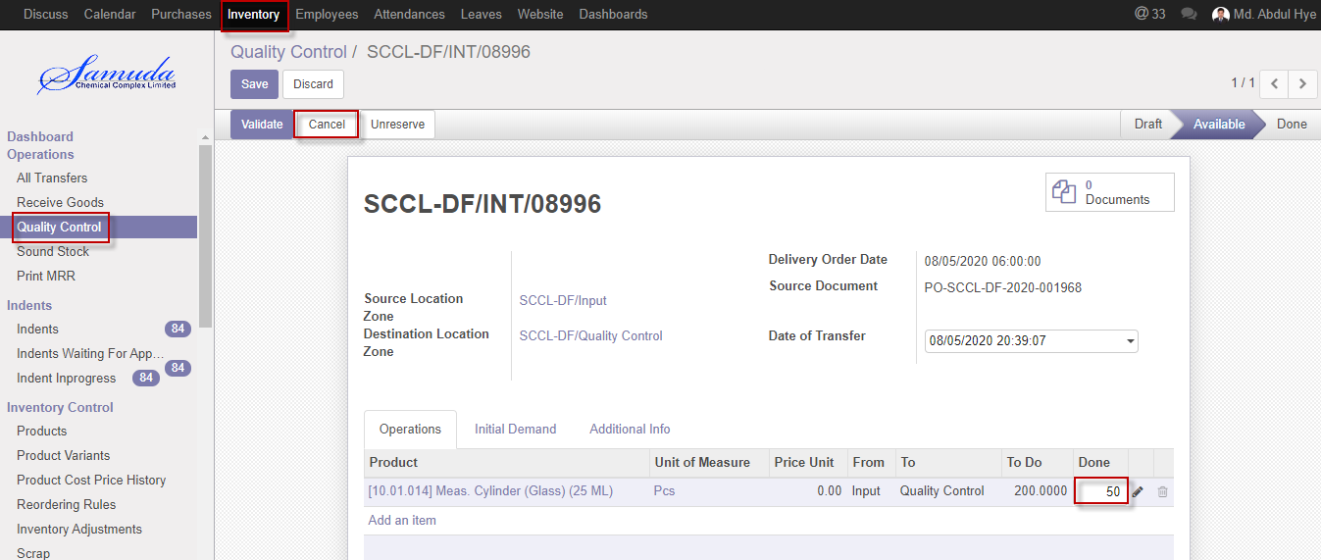

Figure: Cancel Quality control

## 8.2 Partial Quality control creation by Inventory manager

Inventory manager will capable to partial quality control and then will create Backorder.

Inventory manager will create Partial quality control.

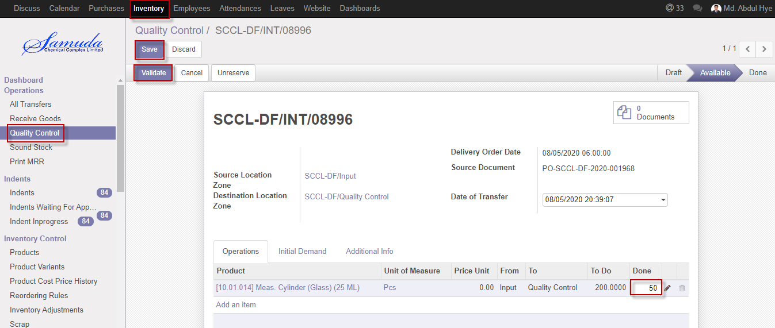

Figure: Partial QC

After click Validate button will open Backorder window then Click **Backorder** buttonthen finally Backorder will go create and QC will done.

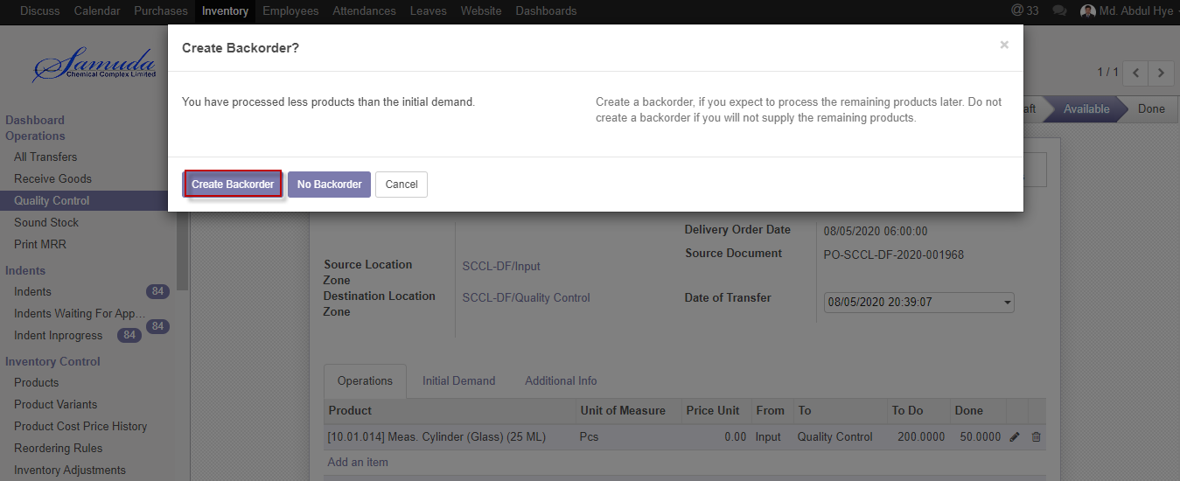

Figure: Create Backorder

# 9. Sound stock

Data will come in sound stock after Quality received. Main stock will be updated after sound stock received.

## 9.1 Sound stock Update by Inventory Manager

Sound stock will be Updated/Edit by Inventory manager

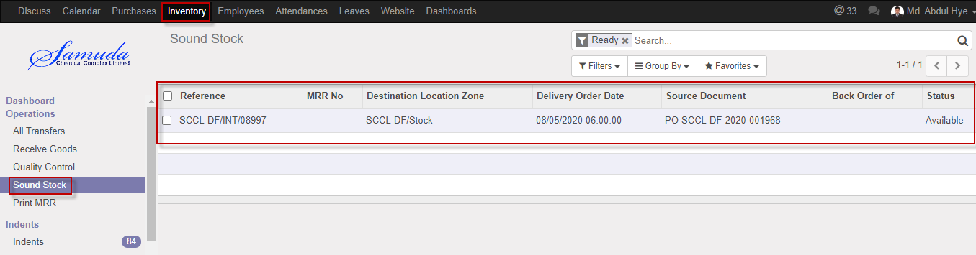

Figure: Sound stock List view

Sound Stock validate will done after click the validate button

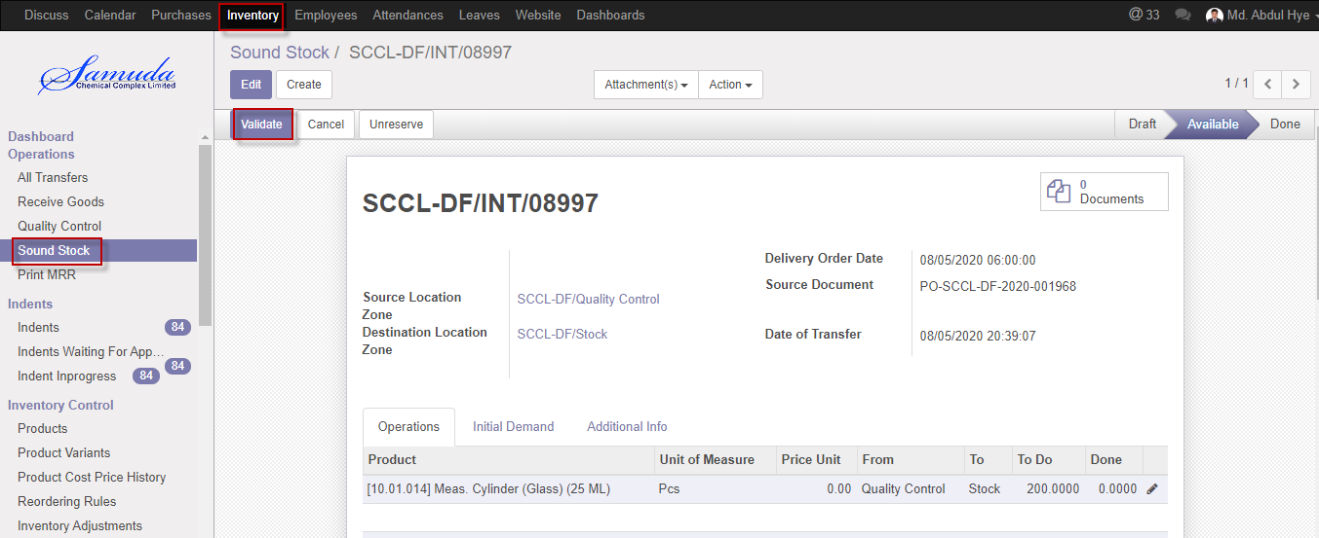

Figure: Validate sound stock

Cancel Sound stock with click **Cancel button.**

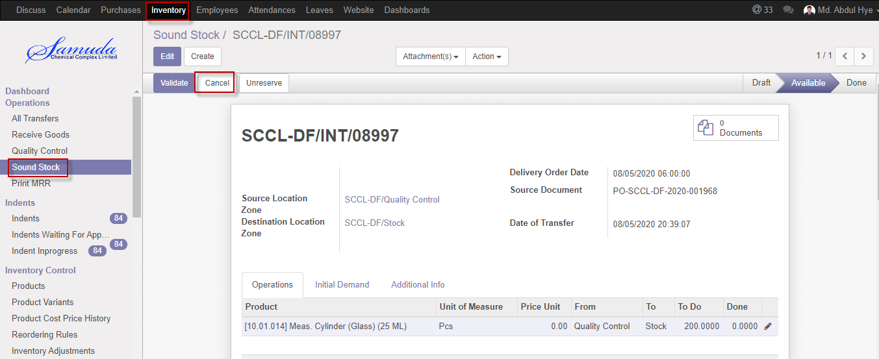

Figure: Cancel Sound stock

## 9.2 Partial Sound stock creation by Inventory manager/user

Inventory manager will capable to partial Sound stock and then will create Backorder.

Inventory manager/user will create Partial Sound stock.

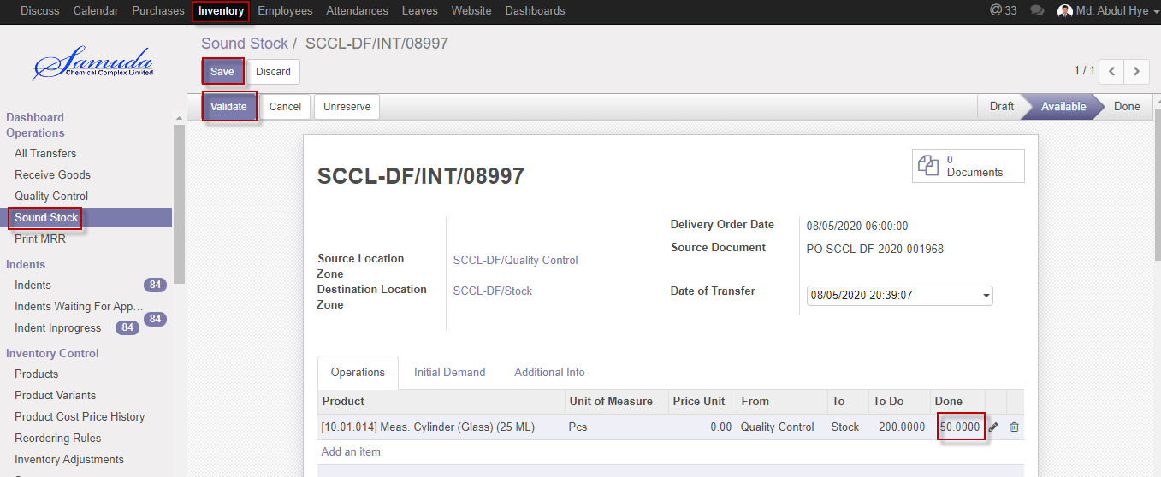

Figure: Partial Sound stock

After click Validate button will open Backorder window then Click **Backorder** buttonthen finally Backorder will go create and Sound stock will update.

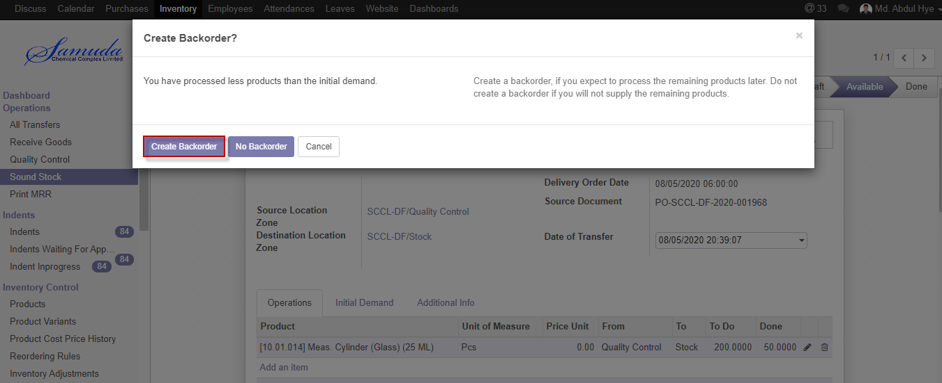

Figure: Create Backorder

# 10. MRR (Accounts approver)

MRR accounts approve will open after sound stock update and then accounts approval show MRR will open. Plant in charge will view show MRR report after Accounts approve.

## 10.1 MRR (Accounts approver) Approved by MRR Accounts Approver

After sound stock update and AC (account) approval MRR will open.

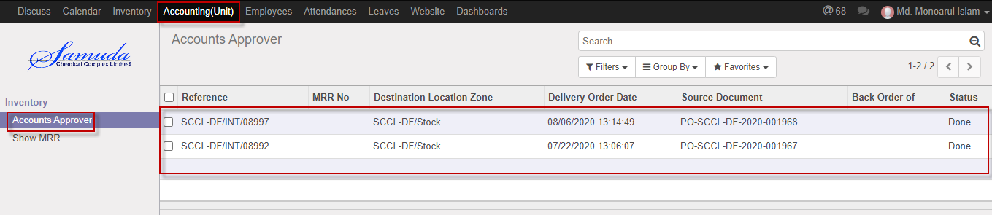

Figure: AC Approve List view

Select a MRR from list then click **AC Approve**

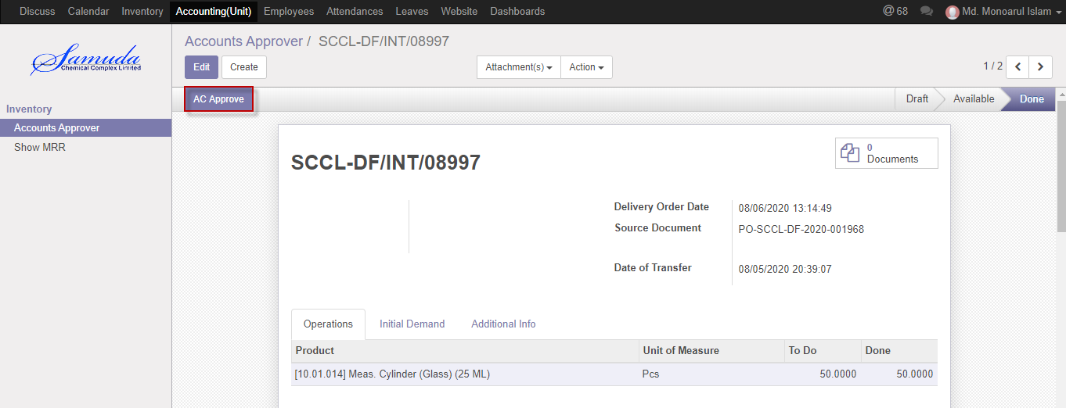

Figure: AC Approve

## 10.2 MRR (Final accounts approver) Approved by Plant in charge

After AC approver Final approves will ready for plant in charge.

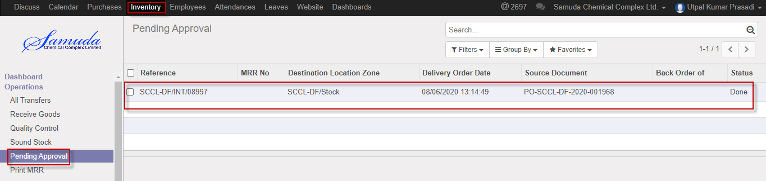

Figure: Pending Approval List view

Select a MRR from list then click **Approve**

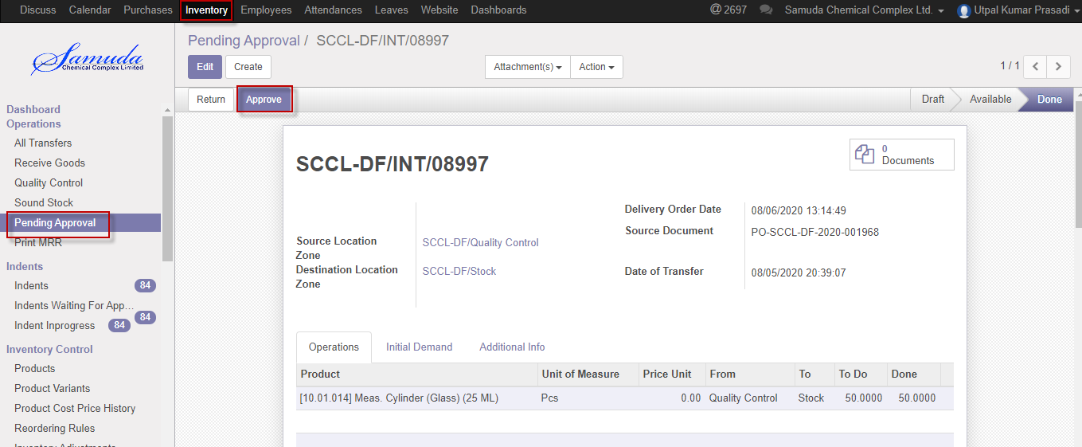

Figure: Pending Approval

# 11. Print MRR

A material receiving report (MRR) is an internal document used to record what materials and inventories were received by the company. The receiving report is sent to other departments to notify them what items have been received and are ready for use. This form is completed immediately upon receipt of materials, supplies, or services. The person receiving the goods will prepare this report. Industry receives all goods by preparing a Material Receiving Repot (MRR).

## 11.1 Print MRR View by Plant In charge

After sound stock update and AC (account) approval MRR will open.

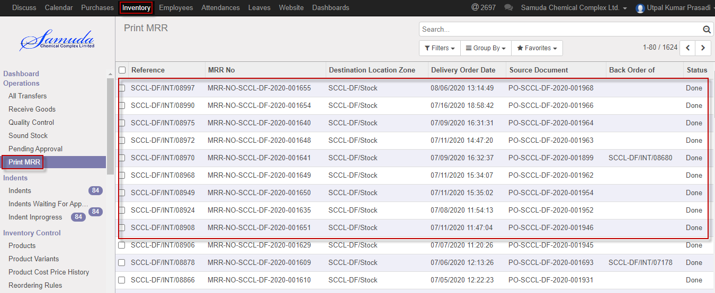

Figure: Print MRR List view

Select a Print MRR from list then click **Print MRR**

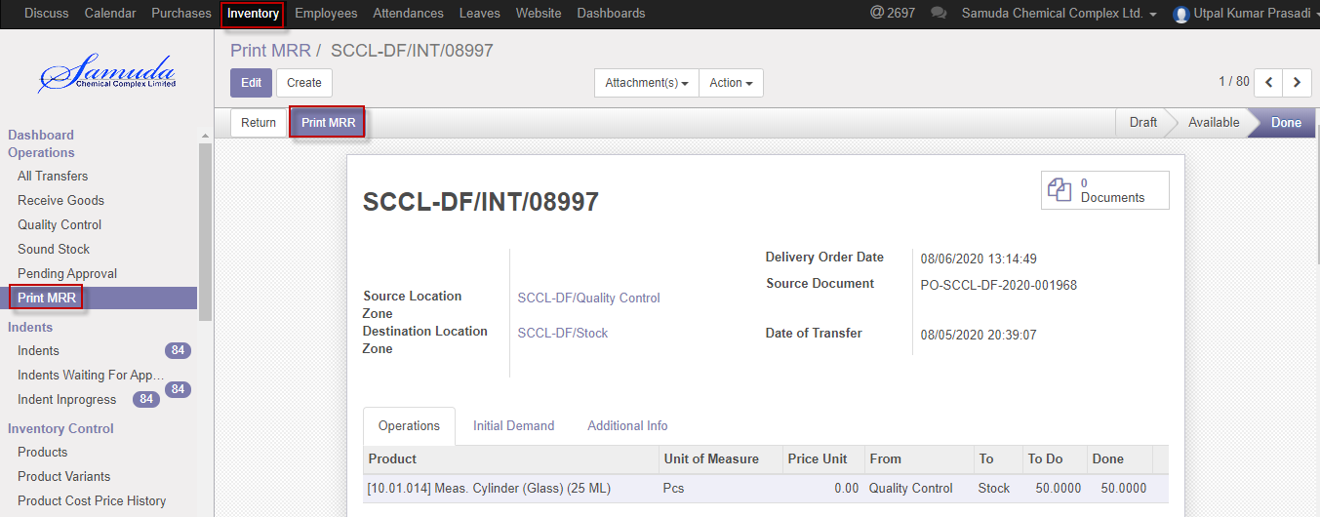

Figure: Print MRR

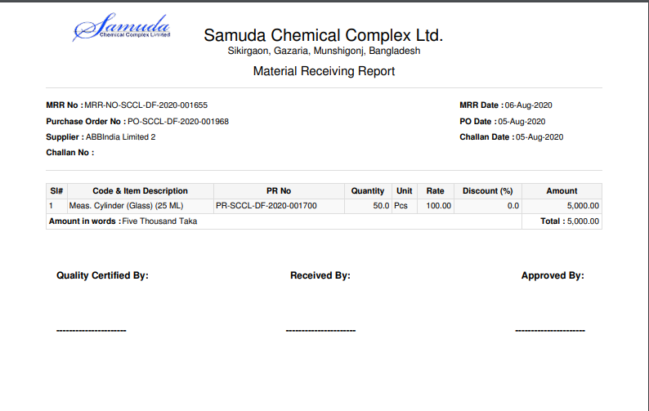

Figure: Print MRR pdf format

# 12. Product on Hands

Product's quantity on hand, it can be retrieved from qty available (Quantity On Hand) field of the Product.  It is a calculated field.  To update, you cannot directly update the qty available field, because it is a calculated field.  You need to actually create a stock move to account for the quantity difference.  Another way it from the Update button next to the qty available field which in turn will call the stock changes. Product qty wizard that will create the new stock. Move.

## 12.1 View on Hands product Inventory Manager

Inventory manager will go product then will view on hands product.

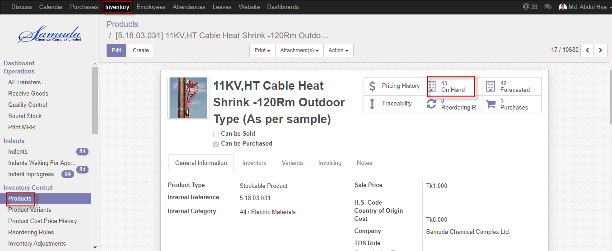

Figure: Product on hands

# 13. Inventory Dashboard

Receive goods, internal transfer, Delivery order will view here.

## 13.1 Inventory dashboard view by Inventory Manager

Inventory Dashboard will view inventory manager/user.

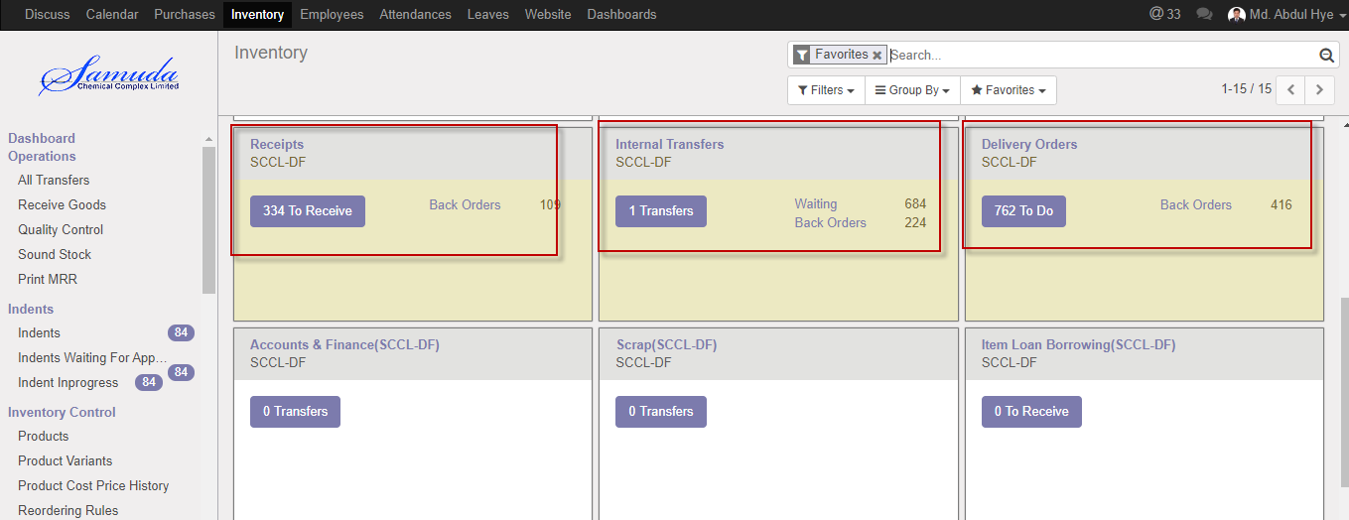

Figure: Inventory Dashboard

**Receipts:** After any product receive will view here.

**Internal transfer:** For Stock move product will view here.

**Delivery order:** Product will view here for Stock delivery.

# 14. Item loan lending

Store keeper will receive loan request for items/goods from other company. Plant Manager will approve the loan request. Goods will be delivered to the other company in mentioned location and it will have gate pass out process as well. The stock will be update automatically when items are delivered to other company.

## 14.1 Item loan lending create by Inventory Manager

Item Loan lending will be Created/Edit by Inventory manager.

After loan lending Product qty will deduct from Main stock.

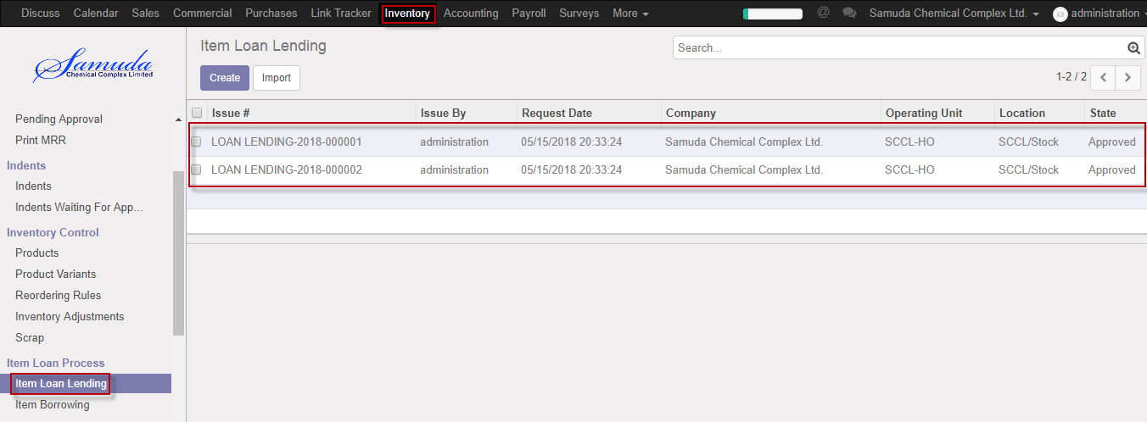

Figure: Item loan lending List view

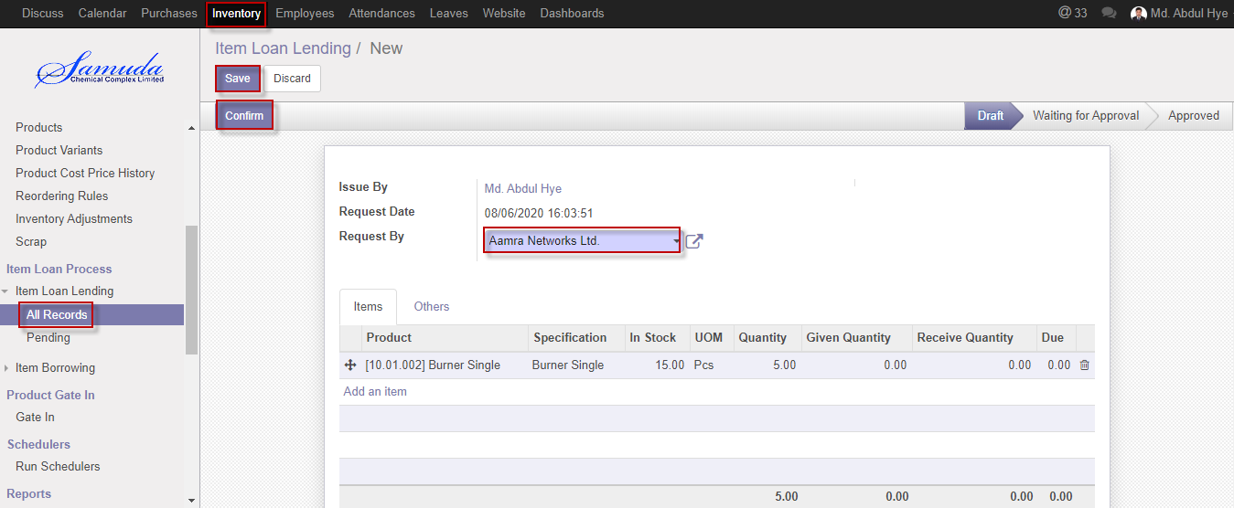

Figure: Item loan lending

## 14.2 Item loan lending Approved by Inventory Manager

Item Loan lending will be Edited & approved by Inventory manager/user.

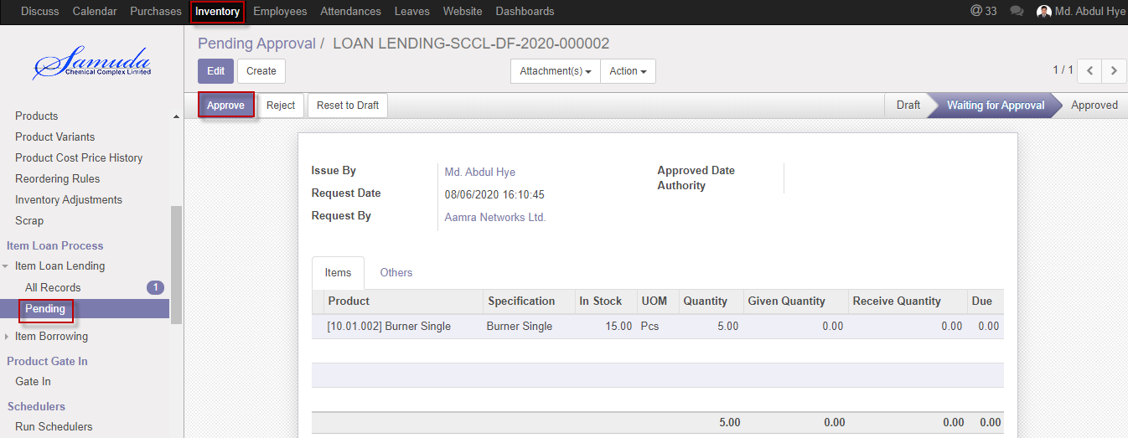

Figure: Item loan lending Approve

Reject item loan lending using **Reject** button

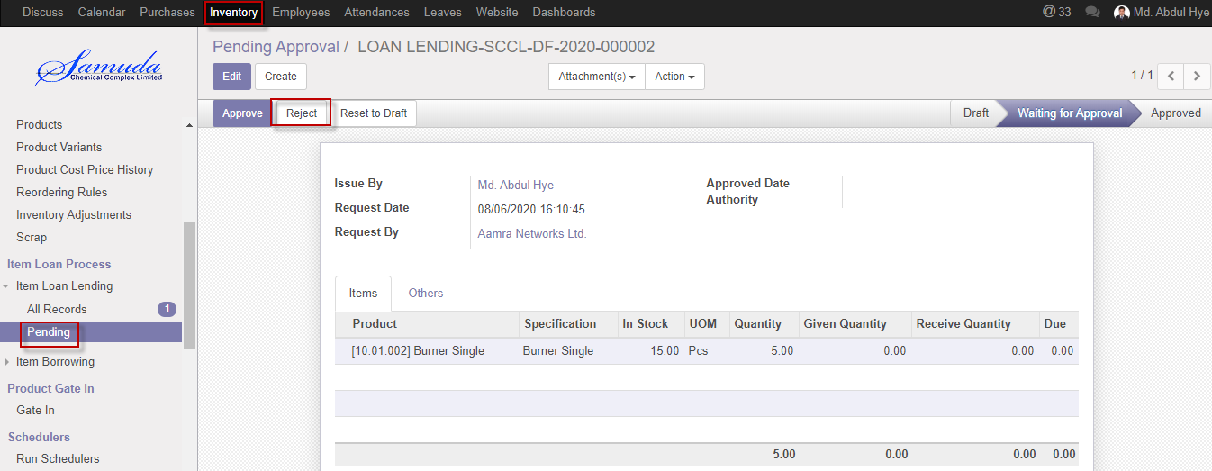

Figure: Item loan lending reject

# 15. Item Borrowing

Store keeper gives requisition for loan items. Plant manager will approve the loan request. Store keeper will receive goods against the loan.

## 15.1 Item Borrowing create by Inventory Manager

Item Borrowing will be Created/Edit by Inventory manager.

After borrowing Product qty will increase in Main stock.

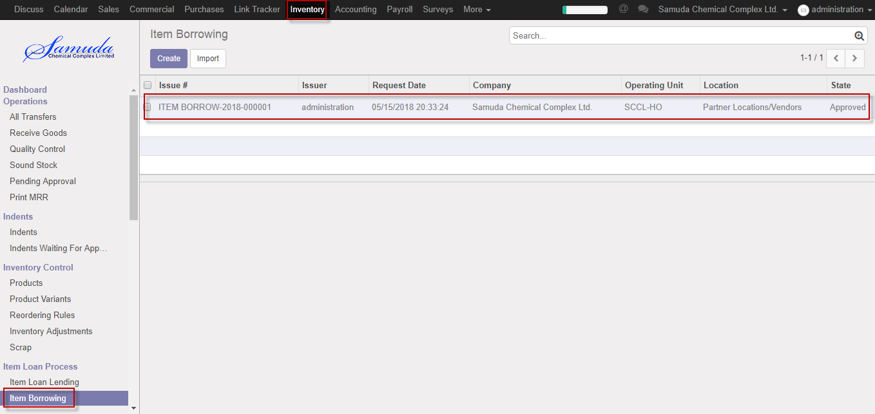

Figure: Item Borrowing List view

After entering all information click **Save and confirm**.

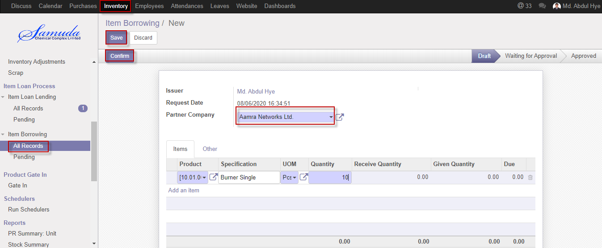

Figure: Item Borrowing

## 15.2 Item Borrowing Approved by Inventory Manager

Item Borrowing will be Edited & approved by Inventory manager.

Item loan borrowing approved using Approve button.

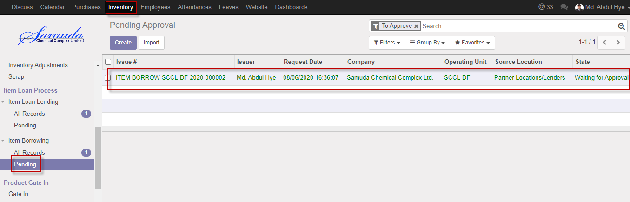

Figure: Pending Approval list view

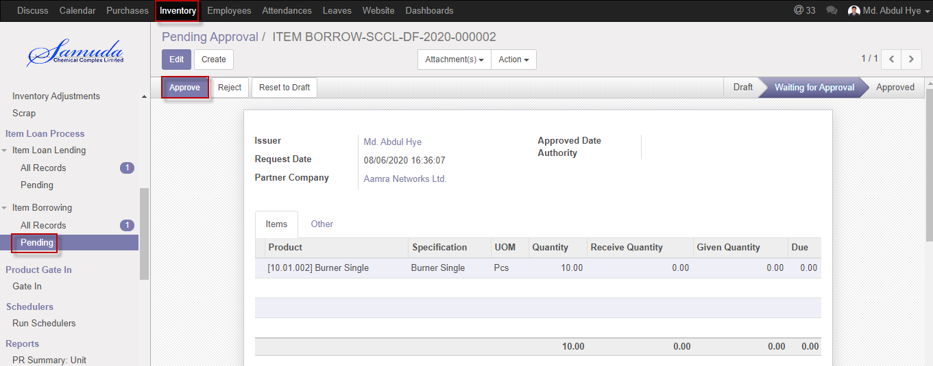

Figure: Item loan Borrowing Approve

Reject item loan borrowing using **Reject** button

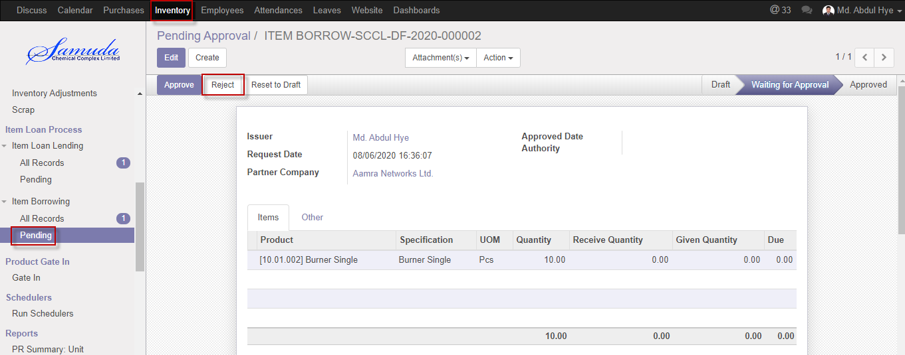

Figure: Item loan borrowing reject

# 16. Scrap

Scrap means waste that either has no economic value or only the value of its basic material

Content recoverable through recycling.

In your warehouse you sometimes find products that are damaged or that are unusable due to expiry or for some other reason. You often notice this during picking or physical inventory.

Since you cannot normally sell or store these products, you have to scrap product.

When goods are scrapped they are not reflected in the system as a part of the inventory. The scrapped material will be physically moved to scrap area.

## 16.1 Scrap create by Inventory Manager

Scrap will be Created/Edit by Inventory manager.

After Scrap Product qty will deduct from Main stock.

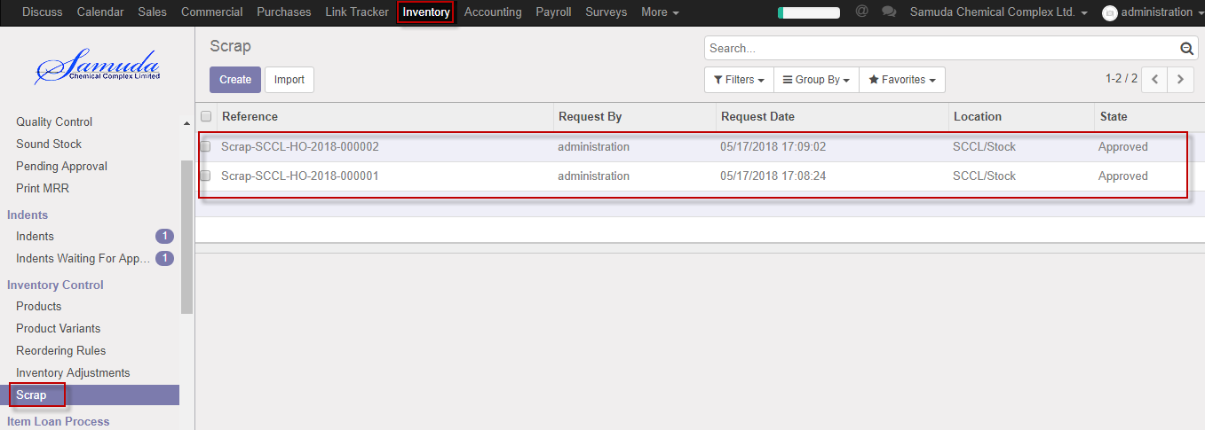

Figure: Scrap List view

After entering all information clicks **Save and confirm**.

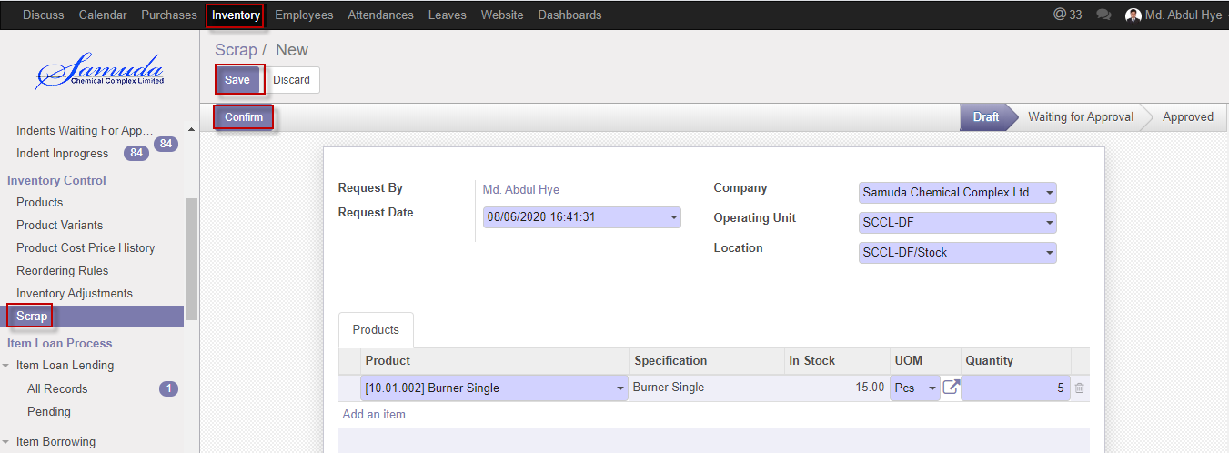

Figure: Create a scrap

## 16.2 Scrap Approved by Inventory Manager

Scrap will be Approved/Edit by Inventory manager.

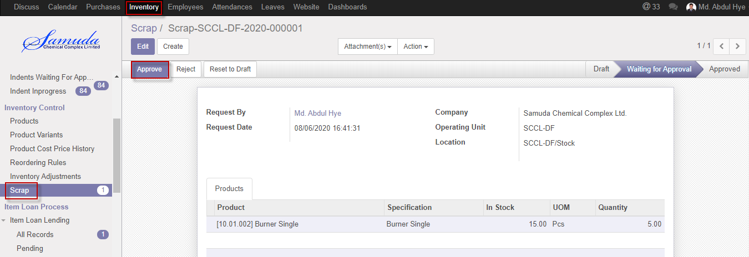

Figure: Approve Scrap

Click **Reject** button for reject Scrap.

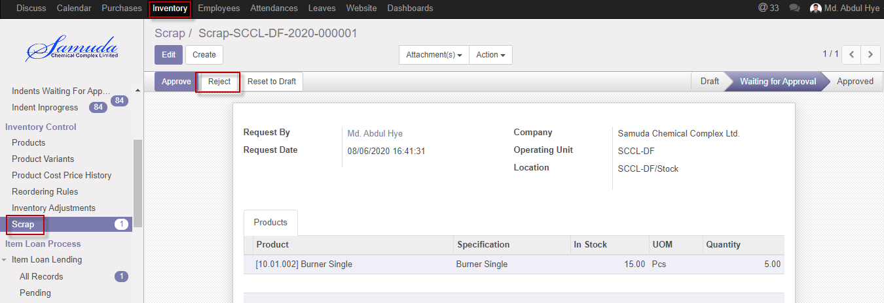

Figure: Reject a scrap

# 17. Reports

In Inventory module reports contain, Stock summary, Purchase reports, Stock transfer etc.

Reports document containing information graphic, or tabular form, prepared on ad hoc, periodic, recurring, regular, or as required basis.

## 17.1 PR Summary view by Inventory manager

Inventory user/manager will view PR summary reports if he/she wants.

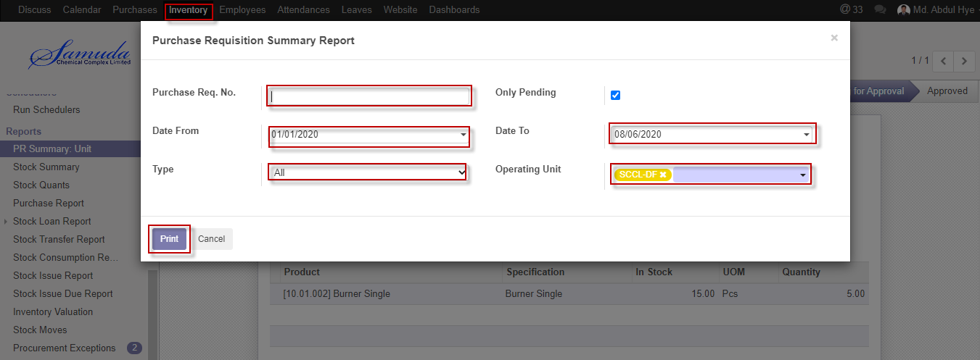

Figure: PR Summary reports print view

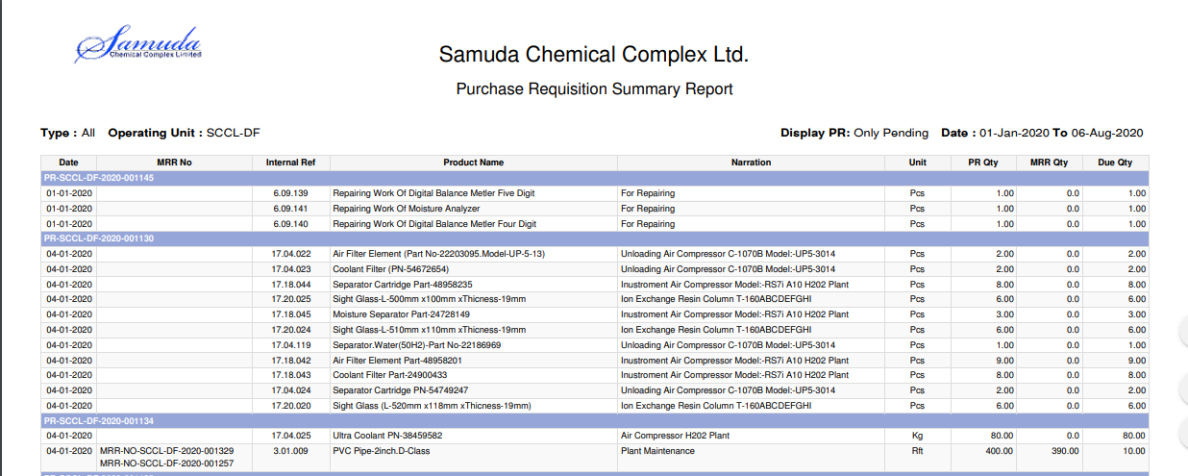

Figure: PR summary report PDF format.

## 17.2 Stock Summary view by Inventory user/manager

Inventory user/manager will view Stock summary reports if he/she wants. Here will show opening, inward, outward & closing Balance

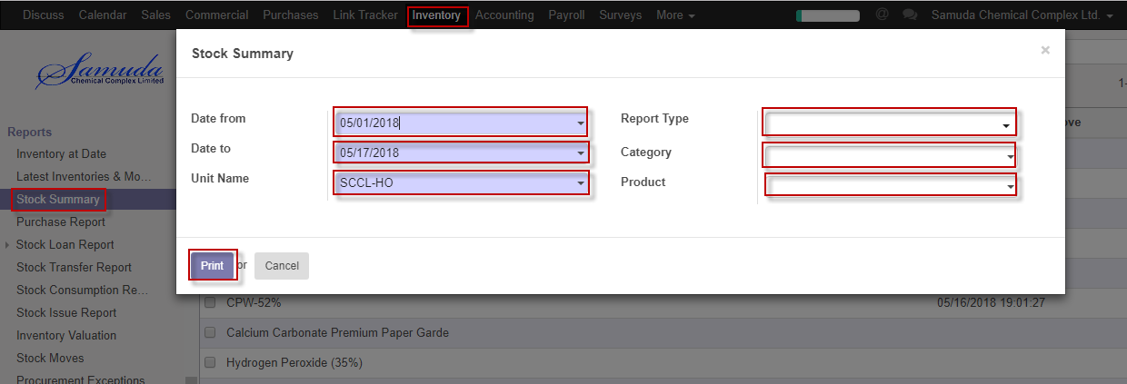

Figure: Stock Summary reports print view

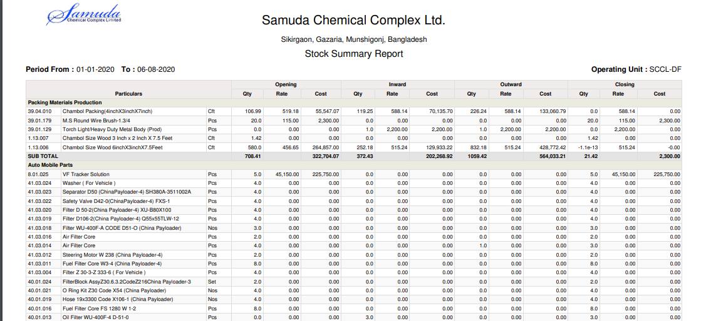

Figure: Stock summary report PDF format.

## 17.3 Purchase reports view by Inventory user/manager

Inventory user/manager will view Purchase reports if he/she wants. Here will show Purchase product information.

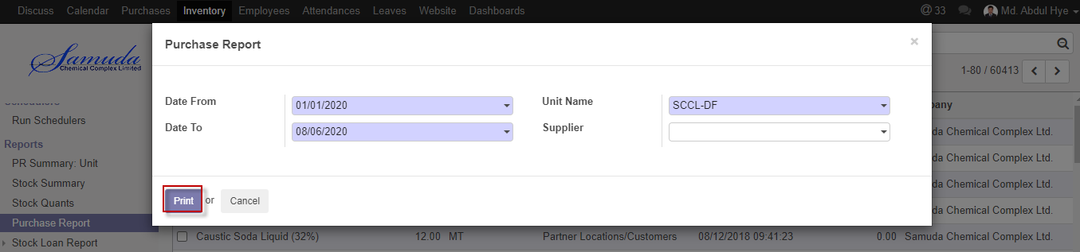

Figure: Purchase reports print view

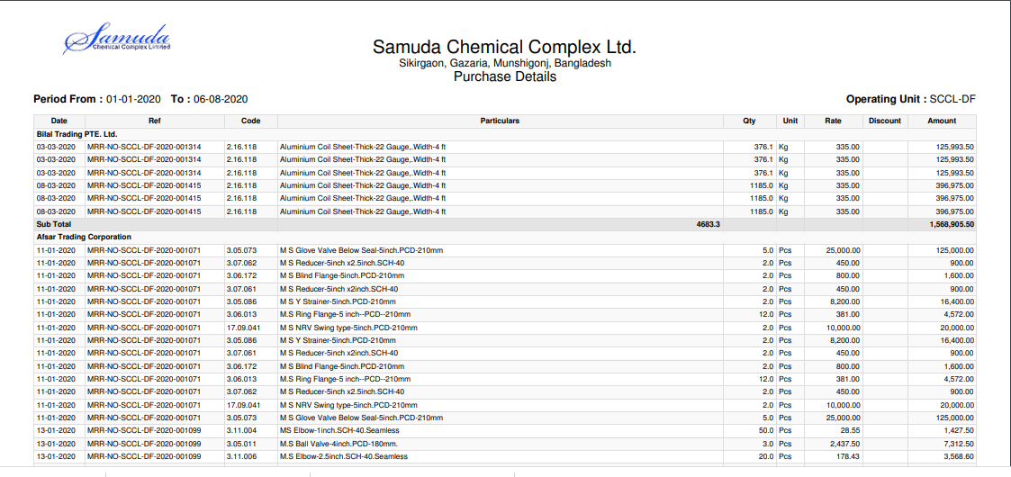

Figure: Purchase report PDF format.

## 17.4 Loan Lending Reports view by Inventory user/manager

Inventory user/manager will view Loan Lending reports if he/she wants. Here will show Company, Date, Operating unit wise, etc. Reports.

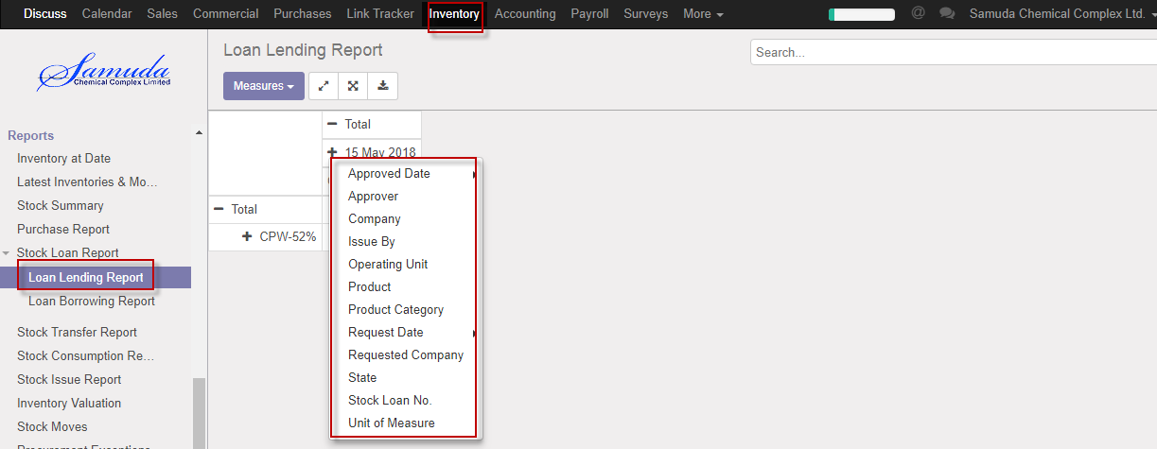

Figure: Loan Lending reports print view

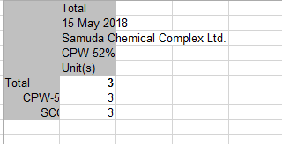

Figure: Loan Lending report Excel format.

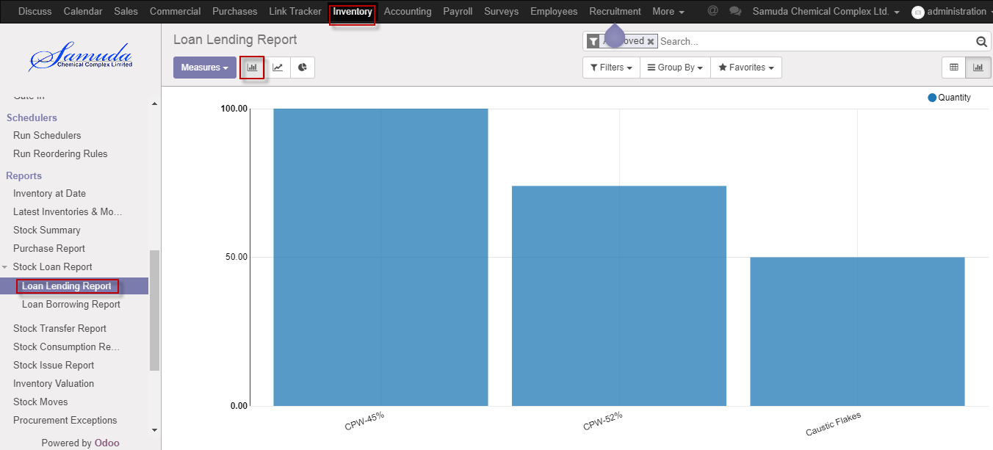

Figure: Loan lending Bar chart view

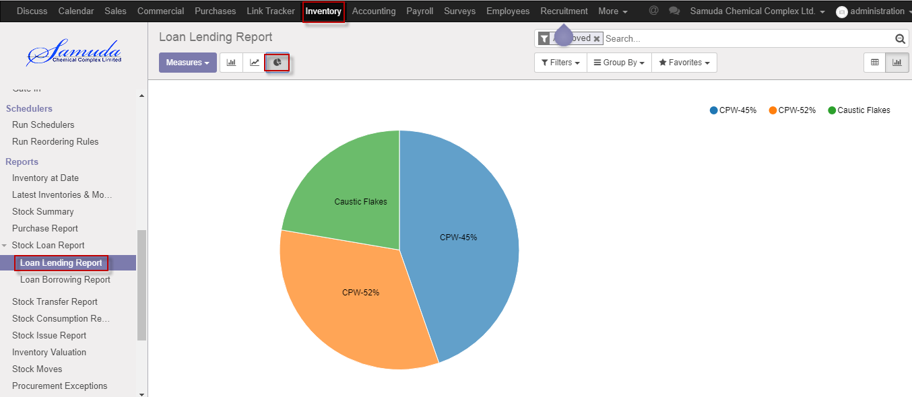

Figure: Loan lending Pie chart view

## 17.5 Loan Borrowing Reports view by Inventory user/manager

Inventory user/manager will view Loan Borrowing reports if he/she wants. Here will show Company, Date, Operating unit wise, etc. Reports.

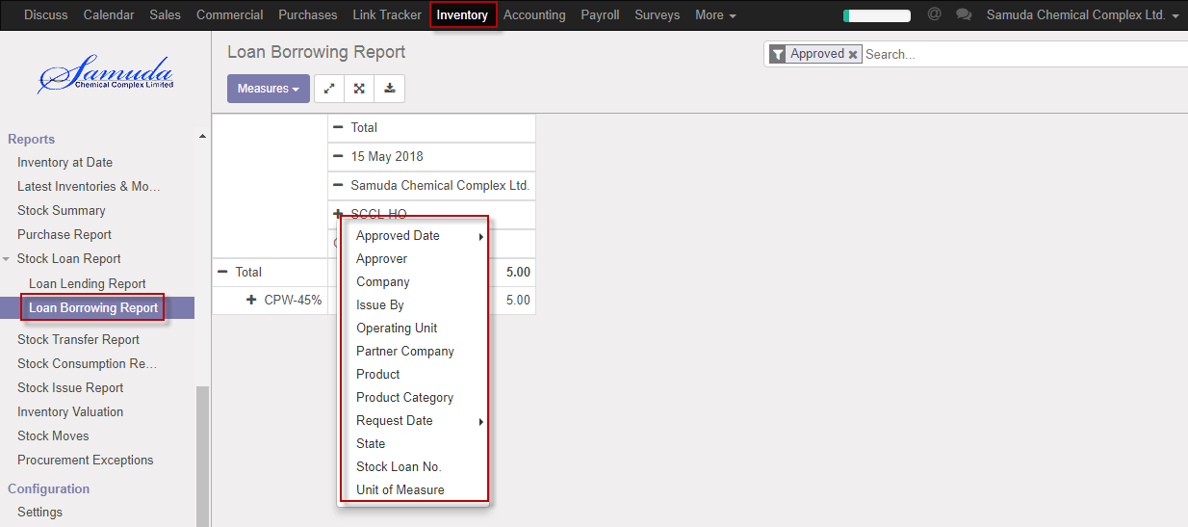

Figure: Loan Borrowing reports print view

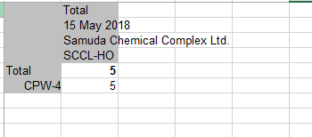

Figure: Loan borrowing report Excel format.

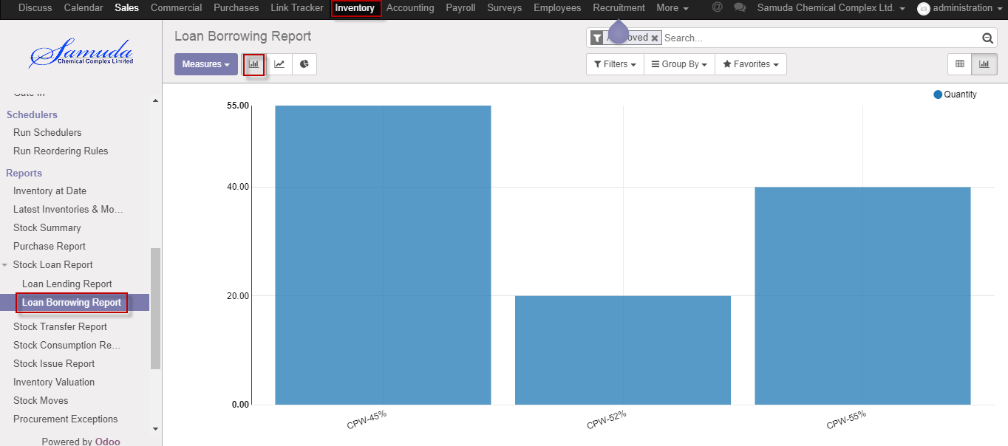

Figure: Loan Borrowing Bar chart view

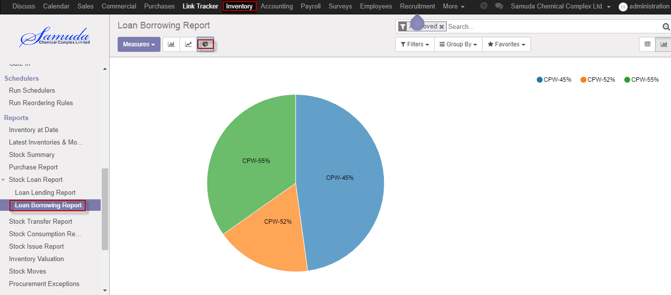

Figure: Loan Borrowing Pie chart view

## 17.6 Stock Transfer view by Inventory user/manager

Inventory user/manager will view Stock Transfer reports if he/she wants. Here will show Stock Move info one stock to another stock.

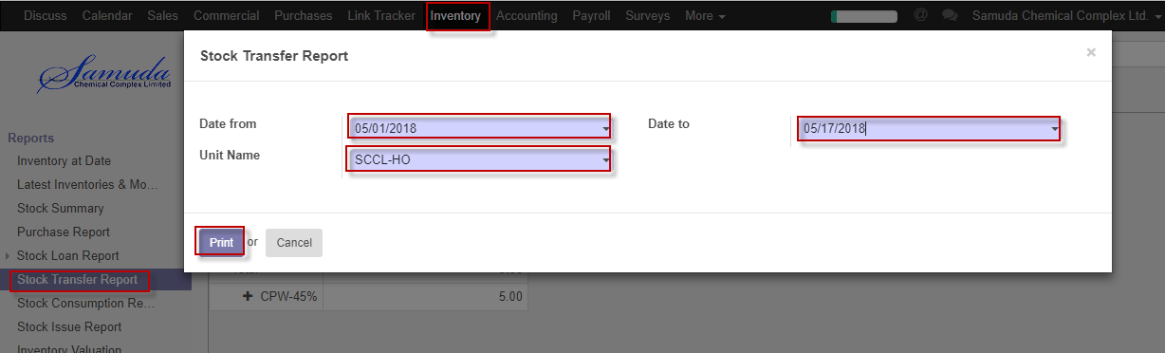

Figure: Stock Transfer reports print view

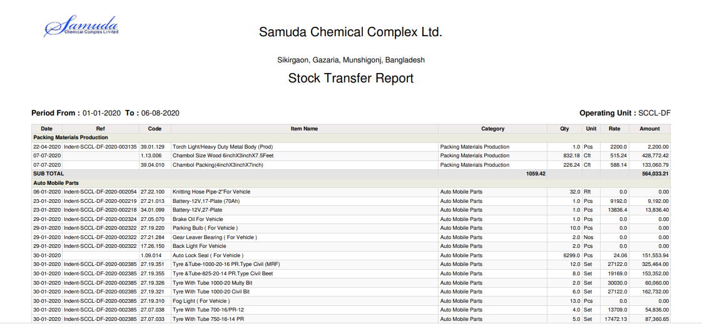

Figure: Stock transfer PDF format

## 17.7 Stock Consumption reports view by Inventory user/manager

Inventory user/manager will view Stock Consumption reports if he/she wants.

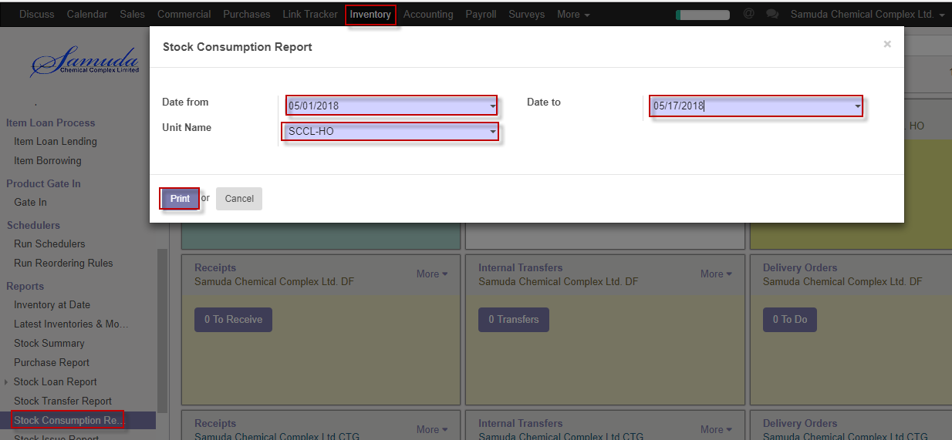

Figure: Stock Consumption reports print view

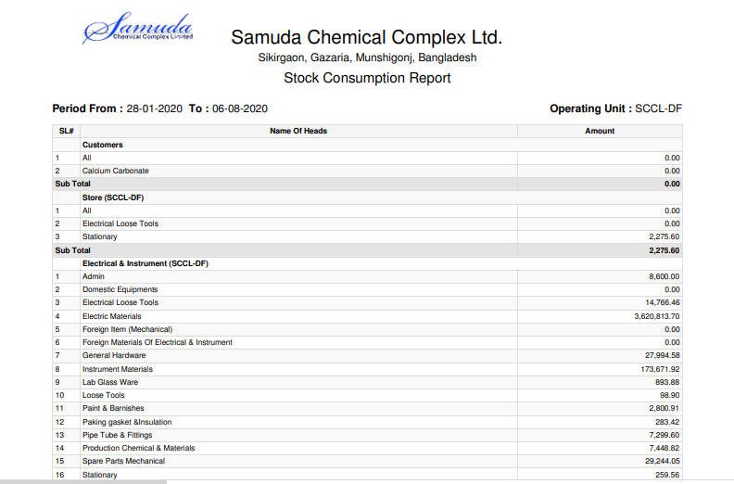

Figure: Stock consumption PDF format

## 17.8 Stock Issue reports view by Inventory user/manager

Inventory user/manager will view Stock Issue reports if he/she wants.

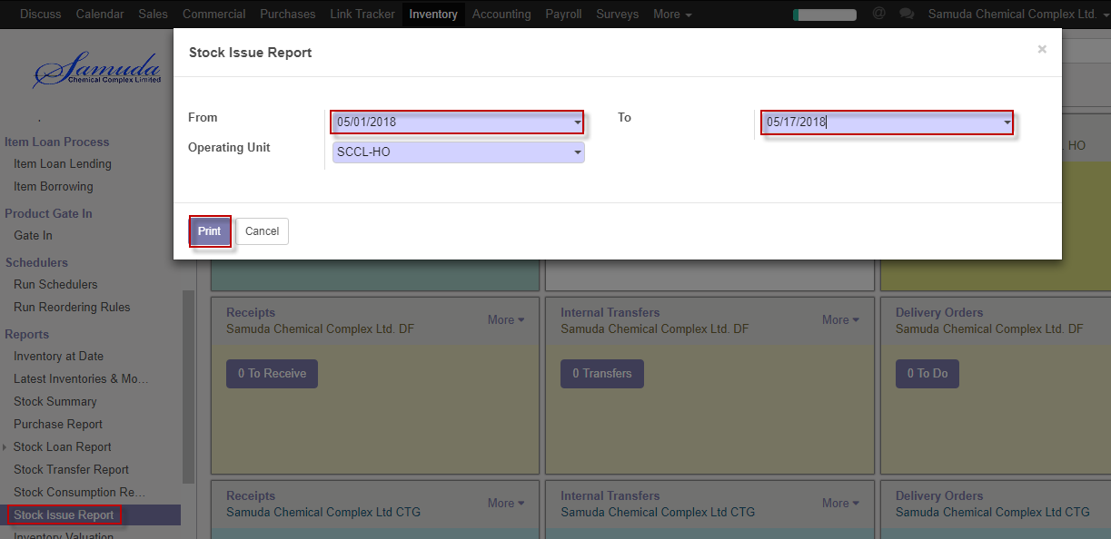

Figure: Stock Issue reports print view

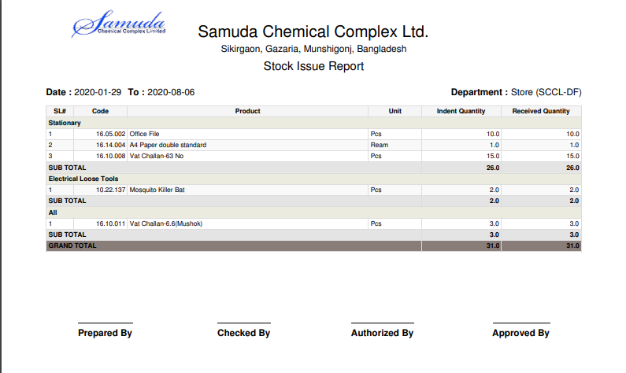

Figure: Stock issue PDF format

## 17.9 Stock Issue Due reports view by Inventory user/manager

Inventory user/manager will view Stock Issue due reports if he/she wants.

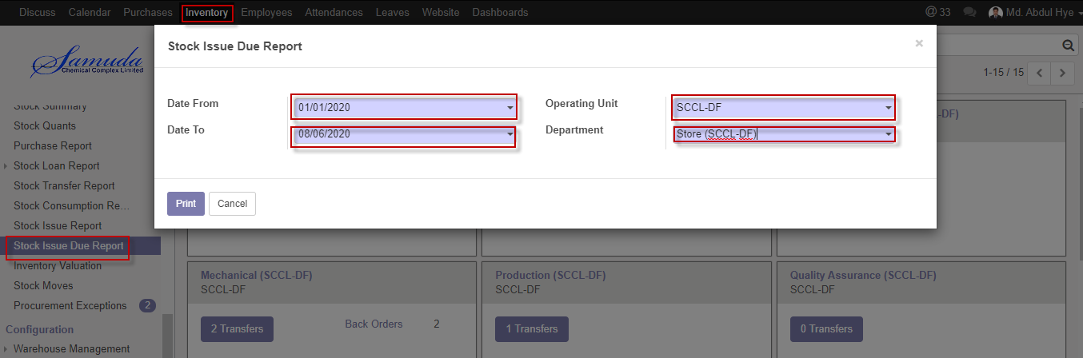

Figure: Stock Issue Due reports print view

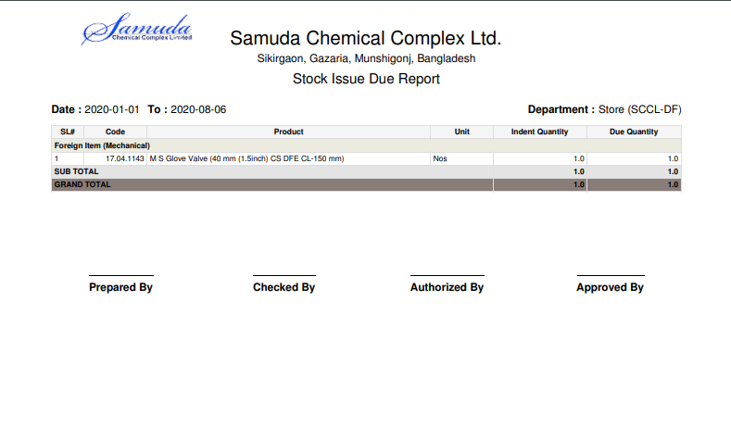

Figure: Stock issue due report PDF format